Science Home learning
We hope you are all doing well at home, well done for doing your science work :-). Below are the email addresses for all Science staff. Do not hesitate to contact any of us with any questions. We even have twitter!
Jamie.venning@astreadearne.org, Thomas.bagnall@astreadearne.org, Danie.cadman@astreadearne.org, sean.guy@astreadearne.org, Kayleigh.smith@astreadearne.org, Robert.gray@astreadearne.org, Vicky.conway@astreadearne.org, dawn.brough@astreadearne.org, Hannah.szabo@astreadearne.org, Richard.white@astreadearne.org, victor.oczadly@astreadearne.org,
Twitter Link: @Dearnescience
L6 Aerobic Respiration Year:
Topic: Biology Unit: Bioenergetics
Date Set:

Information to read / watch:
https://classroom.thenational.academy/subjects-by-key-stage/key-stage-4
Click on Biology, then topic 4 Bioenergetics, lesson 7 Aerobic Respiration
Complete the lesson and the activities
https://app.senecalearning.com/dashboard
Go to AQA biology foundation or higher and choose topic 4 Bioenergetics
Complete sections 4.1 and 4.2

Objectives:
Students should be able to describe cellular respiration as an exothermic reaction which is continuously occurring in living cells.
- State the purpose of respiration in living things
- Explain why the energy transferred by respiration is essential to living things
- Compare the processes of aerobic respiration and photosynthesis

Additional Websites:
https://www.bbc.co.uk/bitesize/examspecs/z8r997h
Read the information for Bioenergetics and complete all the activities.
Self-assess your knowledge using the quiz or exam questions.
ME Task Lesson 6: Aerobic Respiration

Q1.(a) Use words from the box to complete the equation for aerobic respiration.

alcohol | glucose | lactic acid | water

................................ + oxygen carbon dioxide + .............................. (+ energy)
(2)

(b) Some students investigated the effect of temperature on the rate of aerobic respiration in earthworms.
The diagram shows the apparatus the students used.
When the tap is closed, the bead of liquid moves to the left as the earthworms take in oxygen.
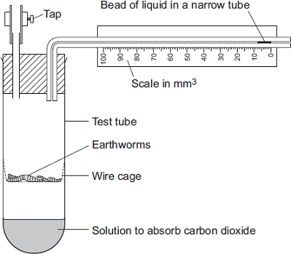
The students put the test tube into a water bath at 20°C for 10 minutes.
They left the tap open during this time.
Why did the students put the test tube in the water bath at 20°C for 10 minutes?
Tick ( ) one box.
Because the air contains more oxygen at 20°C.
Because the air contains less carbon dioxide at 20°C.
So the earthworms’ body temperature would change to 20°C.
(1)

(c) The students then:
• closed the tap
• started a stopwatch
• recorded the position of the bead of liquid every 2 minutes for 10 minutes
• repeated the experiment at 10°C.
The graph shows the students’ results.

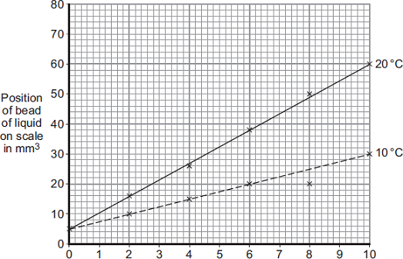
Time in minutes

(i) How much oxygen did the earthworms take in during the 10 minutes at 20°C?
Use information from the graph to work out your answer.
...............................................................................................................
...............................................................................................................
...............................................................................................................
Volume of oxygen taken in = ..................................... mm³

(2)
(ii) The earthworms took in this volume of oxygen in 10 minutes.
Use your answer from part (c)(i) to calculate how much oxygen the earthworms took in each minute.
...............................................................................................................
...............................................................................................................
Volume of oxygen taken in = ........................................ mm³ per minute
(1)

(iii) The earthworms took in less oxygen each minute at 10°C than they took in at 20°C.
Explain why.
...............................................................................................................
...............................................................................................................
...............................................................................................................
...............................................................................................................
(2)

(d) When drawing the line on the graph for the experiment at 10°C, the students ignored the reading at 8 minutes.
(i) Suggest why they ignored the reading at 8 minutes.
...............................................................................................................
...............................................................................................................
(1)

(ii) One student suggested they should repeat the experiment twice more at each temperature.
How would repeating the experiment improve the investigation?
...............................................................................................................
...............................................................................................................
(1)
(Total 10 marks)

Q2. (i) What is the name of the process which takes place in living cells in your body and which releases energy from oxygen and glucose?
.....................................................................................................................................
(1)
(ii) Name the two products of the process in part (i).
............................................................... and ..............................................................
(1)
(Total 2 marks)

Challenge Task- Aerobic Respiration

Hundreds of people everyday use glucose enriched drinks to improve their sporting performance, but do these drinks work? Many studies have been done on the effects of glucose enriched drinks. In this activity you will think about the science behind a glucose enriched drink and why the drink might improve sporting performance.

A group of scientists carried out a test looking at endurance-trained athletes. They gave some of the athletes normal water and some of the athletes water with carbohydrates in. The athletes then trained for two hours. The scientists worked out the difference between the metabolic rates of the athletes.

Describe metabolic rate.
……………………………………………………………………………………………………….

……………………………………………………………………………………………………….

……………………………………………………………………………………………………….

……………………………………………………………………………………………………….

……………………………………………………………………………………………………….

……………………………………………………………………………………………………….

When carrying out the investigation, what would the scientists need to do to make sure that it was a fair test?
……………………………………………………………………………………………………….

……………………………………………………………………………………………………….

……………………………………………………………………………………………………….

……………………………………………………………………………………………………….

……………………………………………………………………………………………………….

……………………………………………………………………………………………………….

Explain why drinking glucose enriched drinks might increase your rate of metabolism.

……………………………………………………………………………………………………….

……………………………………………………………………………………………………….

……………………………………………………………………………………………………….

……………………………………………………………………………………………………….

……………………………………………………………………………………………………….

Why are scientists interested in the metabolic rate of athletes?
……………………………………………………………………………………………………….

……………………………………………………………………………………………………….

……………………………………………………………………………………………………….

……………………………………………………………………………………………………….

The investigation showed that the rate of metabolism does increase if an athlete drinks glucose enriched drink. However, they also found that the amount of glycogen the athletes used up during the training was the same with or without the additional carbohydrates in the water.

What is glycogen?
……………………………………………………………………………………………………….

……………………………………………………………………………………………………….

……………………………………………………………………………………………………….

Why is it important that scientists are not employed directly by any company that produces glucose enriched drinks?
……………………………………………………………………………………………………….

……………………………………………………………………………………………………….

……………………………………………………………………………………………………….

……………………………………………………………………………………………………….

