Science Home learning
We hope you are all doing well at home, well done for doing your science work :-). Below are the email addresses for all Science staff. Do not hesitate to contact any of us with any questions. We even have twitter!
Jamie.venning@astreadearne.org, Thomas.bagnall@astreadearne.org, Danie.cadman@astreadearne.org, sean.guy@astreadearne.org, Kayleigh.smith@astreadearne.org, Robert.gray@astreadearne.org, Vicky.conway@astreadearne.org, dawn.brough@astreadearne.org, Hannah.szabo@astreadearne.org, Richard.white@astreadearne.org, victor.oczadly@astreadearne.org,
Twitter Link: @Dearnescience
L2 Changes in Energy Year: 9
Topic: Physics Unit: Energy
Date Set:

Information to read / watch:
https://classroom.thenational.academy/subjects-by-key-stage/key-stage-4
Click on Physics, then topic Energy
Complete lesson 2

https://app.senecalearning.com/dashboard
Go to AQA Physics foundation or higher and choose topic Energy
Complete section 1.1.2 Calculating Energy Changes

Objectives:
Students should be able to calculate the amount of energy associated with a moving object, a stretched spring and an object raised above ground level.
Calculate the kinetic energy of objects using the equation
Calculate the elastic energy of objects using the equation
Calculate the gravitational energy of objects using the equation

Additional Websites:
GCSE Combined Science - AQA Trilogy - BBC Bitesize
Click Energy and review the topic
Kinetic energy calculations

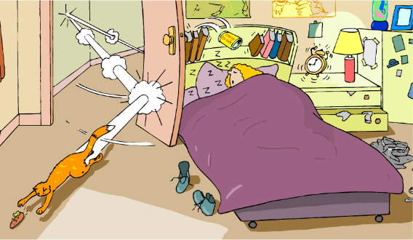
Support
The word ‘kinetic’ comes from the Greek word ‘kinesis’, meaning motion. Kinetic energy is the energy an object has because it is moving. All moving things have kinetic energy, but the amount of energy they have is not just dependent on how fast they are moving.

How is kinetic energy calculated?
The kinetic energy (E_{k}) of an object can be calculated using this equation:

- mass is measured in kilograms (kg).
E_{k} = ½ x mass x velocity²
= ½mv²
- Velocity is measured in metres per second (m/s).
- E_{k} is measured in joules (J).

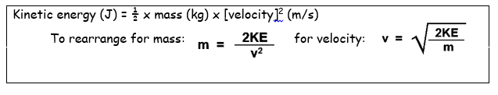

Calculating kinetic energy question
A car with a mass of 1,500 kg travels at a velocity of 20 m/s.
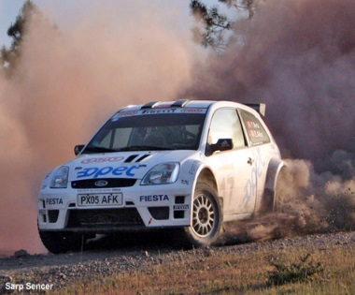
What is the kinetic energy of the car?
kinetic energy = ½ x mass x velocity²
E_{k} = ½ mv²
= ½ x 1,500 x 20²
= 300,000 J = 300 kJ

½m x v²

Kinetic energy calculations

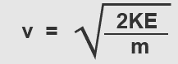
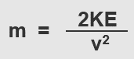
Kinetic energy (J) = ½ x mass (kg) x [velocity]² (m/s)
To rearrange for mass: for velocity:

Foundation
- A car that travels at a speed of 20m/s and has a mass of 1200 kg.
- A year 11 pupil with a mass of 55kg swinging back on their chair and falling off it at a speed of 0.6m/s.
- A runner with a mass of 62kg running at a speed of 0.8m/s.
- A tennis ball travelling at a speed of 46m/s with a mass of 58kg.
- A dog running across a field at a speed of 1.2m/s with a mass of 3.2kg.

Kinetic energy Standard
- A raging bull of mass 700kg runs at 10 m/s. How much kinetic energy does it have?

7 A waddling armadillo of mass 500kg moves at 5 m/s. How much kinetic energy does it have?

8 A stroppy teenager throws their PS4 controller at the wall after losing at FIFA. It has 78.125J of kinetic energy and moves at 25 m/s before it hits the wall. How much mass does it have?

9. A slightly disturbed man of 80kg runs directly into a wall with a kinetic energy of 4000J. How fast is he running?

Calculating velocity Higher/ Challenge

11.Bus travelling through town, with a mass of 5040kg and kinetic energy of 493900J.

12. A lift travelling up to the top floor of the Empire State building with a mass of 4200kg and a kinetic energy of 4116J.

13. Bird flying towards its nest with a mass of 0.25kg and a kinetic energy of 40.5J.
14. A remote flung from a hand through a TV, with a kinetic energy of 1.44J and a mass of 4.5kg.
15. Hot air balloon with a kinetic energy of 76550J and a mass of 1890kg.

Calculating mass: Higher/ Challenge

16. Automatic door closing 0.2m/s, with a kinetic energy of 1.6J.
17.Wind turbine blade with a kinetic energy of 104040J, turning at 6m/s.
18. Aeroplane travelling at 75m/s with a kinetic energy of 843700J.
19. Canoe moving down the river with a kinetic energy of 5J and a speed of 0.5m/s.
20. Child riding a bike at a speed of 6m/s, with a total kinetic energy of 1224J. If the mass of the child is 30kg, what is the mass of the bike?

Elastic potential energy – complete the paragraph, filling in the gaps with the words underneath.
Elastic potential energy is the energy ______________ in anything that is ____________ or ______________. The amount of energy depends on how much the thing is stretched or squashed by, we call this the _______________________. To work out the ____________________ you do: Extension = new length - original length. The extension is measured in _____________. The elastic potential energy also depends on ____________ ___________, which tells us how easy or difficult it is to stretch the thing.

Complete the table using the equation given
Spring constant (N/m) | Extension (m) | Working  Type: 0.5 x spring constant x extension x extension | Elastic potential energy (J)
30 | 0.3
200 | 4
1 | 0.04
17 | 22
55 | 5
5.9 | 1
77 | 0.4
1500 | 0.09

Support
spring constant stored extension stretched extension squashed meters

