Science Home learning
We hope you are all doing well at home, well done for doing your science work :-). Below are the email addresses for all Science staff. Do not hesitate to contact any of us with any questions. We even have twitter! Twitter Link: @Dearnescience
Jamie.venning@astreadearne.org, Thomas.bagnall@astreadearne.org, Danie.cadman@astreadearne.org, sean.guy@astreadearne.org, Kayleigh.smith@astreadearne.org, Robert.gray@astreadearne.org, Vicky.conway@astreadearne.org, dawn.brough@astreadearne.org, Richard.white@astreadearne.org, victor.oczadly@astreadearne.org,
s
Lesson 4: Title: Formulae Year: 7
Topic: Chemistry Unit: Elements
Date Set:

Learning Objectives:
Know how to interpret the formulae of molecular compounds and elements.

Understand the meaning of coefficients and subscript values in formulae.

Understand the relationship between microscopic properties, macroscopic properties and formulae (Johnstone’s Triangle).

Information to read / watch:
Chemical formulae (thenational.academy)
https://www.youtube.com/watch?v=vhSc_oqeN5w
Symbols and formulae - BBC Bitesize
Application:
Task 1: List the number of atoms in each formula
Task 2: How many elements & atoms in each formula?
Task 3: How many molecules
Task 4: Information from formulae

Task 1: List the number of atoms in each formula

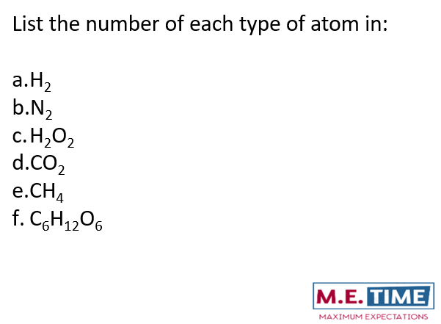

Task 2: How many elements & atoms in each formula

Task 3: how many molecules in each case
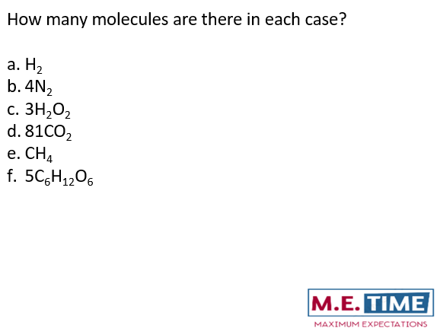

Task 4: Information from formulae

