Science Home learning
Lesson Title: Organisation 1 Year:
Topic: Organisation Unit: Biology

Date Set:

Information to read / watch:
https://www.bbc.co.uk/bitesize/guides/zgcxsbk/revision/1
Application:
Please see the exam-style questions that accompany this sheet. You must complete the questions and then self-assess using the mark scheme that has been provided.

Additional Websites:
https://www.youtube.com/watch?v=VO2QkpwAG9o
https://www.youtube.com/watch?v=3CFsOAybTO8
Organisation – Plant tissue and transpiration M.E. Time Task

Objective: Students should be able to explain how the structure of root hair cells, xylem and phloem are adapted to their functions.

Task 1

Plants absorb water from the soil by osmosis. The diagram below shows a root hair cell.
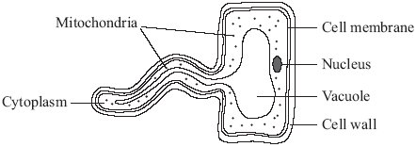

- Describe and explain how the root hair cell is adapted to absorb water?
___________________________________________________________________
___________________________________________________________________
___________________________________________________________________
___________________________________________________________________
___________________________________________________________________
___________________________________________________________________
(4)
(b) Xylem transport water around the plant, whilst phloem transport food around the plant. For each one describe a feature and how this adaptation allows it to do its job.
Xylem:
___________________________________________________________________
___________________________________________________________________
___________________________________________________________________
Phloem: ___________________________________________________________________
___________________________________________________________________
___________________________________________________________________
(4)

Task 1 Mark Scheme

- Describe: Large surface area
Explain: Maximum absorption of water

D: Thin membrane
E: Allows absorption of water easily

D: Large permanent vacuole
E: To absorb maximum amount of water

D: No cuticle
E: Allows easier absorption

- Xylem
Describe: Long hollow cells
Explain: Allows water to travel easily

D: Reinforced lignin walls
E: Makes them strong

D: Reinforced lignin walls
E: Waterproof – no water is lost

Phloem:
Describe: Sieve plates
Explain: Allow for continuous passage of sugars

D: Companion cell (with many mitochondria) & Limited amount of cytoplasm
E: To allow for efficient transport of sugars.
E: To provide energy for active transport

D: Two way flow.
E: So all parts of plant can receive sugar.

Organisation – Plant tissue and transpiration M.E. Time Task

Objective: Students should be able to explain the effect of changing temperature, humidity, air movement and light intensity on the rate of transpiration.
Task 2:

Some students used the apparatus shown in the diagram to measure the rate of water uptake by a plant cutting.
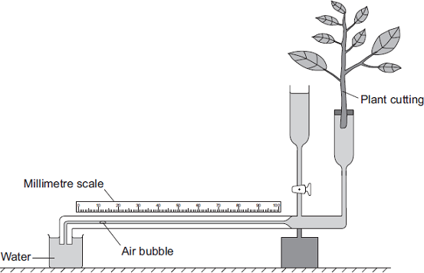
The students set up the apparatus in three different
Conditions:
• no wind at 15°C
• no wind at 25°C
• wind at 25°C
For each experiment, the students recorded the movement of the air bubble along the scale.

(a) Name the two variables the students chose to change in these experiments.
1. ____________________________________________________________
2. ____________________________________________________________
(2)
(b) The graph shows the students’ results.
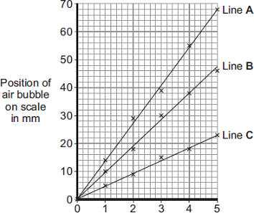
Time in minutes

Which line on the graph, A, B or C, shows the results for each of the three different experiments?
Write each of the letters, A, B and C, in the correct boxes in the table.

Conditions | Letter
No wind at 15°C
No wind at 25°C
Wind at 25°C
(2)

(c)
The rate of transpiration is also affected by factors other than temperature and wind (air movement). Describe and explain how different levels of humidity and light intensity will affect the rate of transpiration.

________________________________________________________________________________________________________________________________________________________________________________________________________________________________________________________________________________________________________________________________________________________________________________________________________________________________________________________________________________________________________________________________________________________________________________________________________________________________________________________________________________________________________________________________________________________________________________________________________________________________________________________________________________________________________________________________________________________________________________________________________________________________________________________________________________________________________________________________________________________________________________________________________________________________________________________________________________
(4)

(a) (i) wind
answers in either order
1
temperature
ignore weather
1
(b) in table, in sequence:
C
B
A
all 3 correct = 2 marks
2 correct = 1 mark
0 or 1 correct = 0 marks
max 2
(c

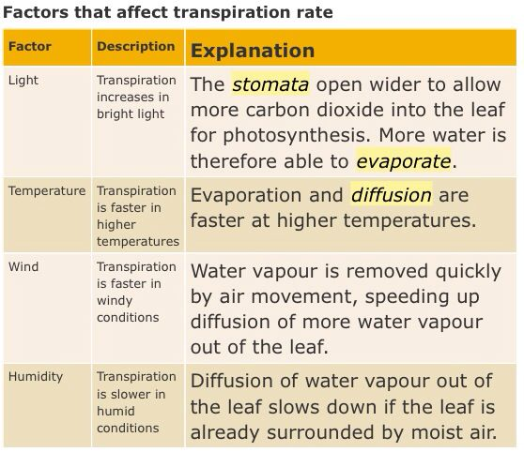

Organisation – Plant tissue and transpiration M.E. Time Task

Objective: Students should be able to understand and use simple compound measures such as the rate of transpiration. (MS 1a, 1c)
Objective: Students should be able to describe the process of transpiration and translocation, including the structure and function of the stomata.
Task 3:

1) Explain the difference between translocation and transpiration.

____________________________________________________________________________________________________________________________________________________________________________________________________________________________________________________________________________________________________________________________________________________________
(2 Marks)

The graph shows the rate of transpiration from a plant at different times of the day.
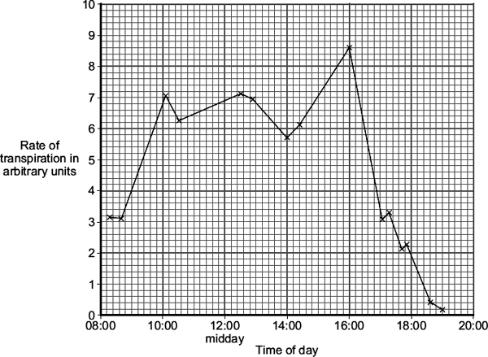

Transpiration occurs mainly in the leaves of a plant. Explain what transpiration is and its importance and why it occurs at different rates. Use data from the graph to support your explanation.
(6 MARKS)

________________________________________________________________________________________________________________________________________________________________________________________________________________________________________________________________________________________________________________________________________________________________________________________________________________________________________________________________________________________________________________________________________________________________________________________________________________________________________________________________________________________________________________________________________________________________________________________________________________________________________________________________________________________________________________________________________________________________________________________________________________________________________________________________________________________________________________________________________________________________________________________________________________________________________________________________________________________________________________________________________________________________________________________________________________________________________________________________________________________________________________________________________________________________________________________________________________________________________________________________________________________________________________________________________________________________________________________________________________________________________________________________________________________________________________________________________________________________________________________________________________________________________________________________________________________________________________________________________________________________________________________________________________________________________________________________________________________________________________________________________________________________________________________________________________________________________________________________________

Task 3 Mark scheme:

Level 3: Provides a clear and logical explanation of transpiration and its importance including role of stomata and supported with a least two sets of data from the graph.
Level 2: Provides a clear and logical explanation of transpiration and the role of stomata.

Level 1: Attempts to describe the role of stomata or attempts to describe Transpiration.
5-6
3-4
Indicative Content
Transpiration is water loss
As a vapour / by evaporation

Stoma controlled by guard cells

Guard cells change shape due to water content

Rate of transpiration is higher during warm and sunny conditions

Transpiration is required as the transpiration stream moves minerals dissolved in water through the plant.

1-2

Tissue | Process | What is moved
Xylem | Transpiration | Moves water and minerals from roots to leaves
Phloem | Translocation | Moves food substances from leaves to rest of plant and from stores such as in the roots

