Science Home learning
Lesson Title: Organisation 1 Year:
Topic: Organisation Unit: Biology

Date Set:

Information to read / watch:
https://www.bbc.co.uk/bitesize/guides/zgcxsbk/revision/1
Application:
Please see the exam-style questions that accompany this sheet. You must complete the questions and then self-assess using the mark scheme that has been provided.

Additional Websites:
https://www.youtube.com/watch?v=VO2QkpwAG9o
https://www.youtube.com/watch?v=3CFsOAybTO8
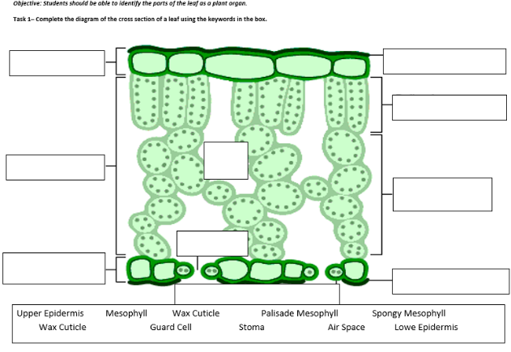

Objective: Students should be able to explain how the structures of plant tissues are related to their functions.
Task 2:
Complete the table below to show each part of the leaf organ is adapted to its function
Leaf Structure / Cell | Function | Adaptation
Waxy Cuticle
Epidermis
Palisade Mesophyll
Spongy Mesophyll
Stomata
Guard Cell

Objective: Students should be able to explain how the structures of plant tissues are related to their functions.
Task 3:

Leaves are made from layers of cells.
The diagram shows a section through part of a leaf.
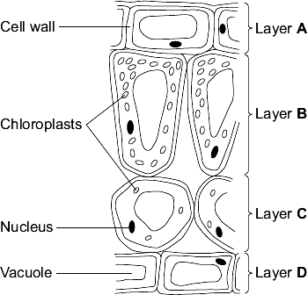
Identify each layer and explain how that structure is adapted to its function.

_______________________________________________________________________________
_______________________________________________________________________________
_______________________________________________________________________________
_______________________________________________________________________________
_______________________________________________________________________________
_______________________________________________________________________________
_______________________________________________________________________________
_______________________________________________________________________________
_______________________________________________________________________________
_______________________________________________________________________________
_______________________________________________________________________________
_______________________________________________________________________________
____________________________________________________________________________ (6)
Indicative Content:
Epidermis (upper)
Waxy waterproof layer.
Reduce water loss.
Thin layer allows light to pass through

Palisade Mesophyll
Contains palisade cells. / lots of chloroplasts
Absorbs maximum amount of light possible.

Spongy mesophyll
Irregular shape / increased surface area.
Increased absorption / space creates area for diffusion of gases.

Epidermis (Lower)
Guard cells / Stomata
Open / close to reduce water loss / absorb carbon dioxide.

1-2
Level 1: some sections of the leaf are correctly identified
or
some of the structures have been described in terms of their adaptations
or
some of the structures have been described in terms of their role within the leaf.
3-4
Level 2: All four sections of the leaf are correctly identified
and
All four sections are described in terms of their adaptations with some explanation of how they relate to their functionary role.
5-6
Level 3: All four sections of the leaf are correctly identified
and All four sections are described in terms of their adaptations and how they relate to their functionary role.

