Science Home learning
Lesson Title: Organisation 13 Year:
Topic: Organisation Unit: Biology

Date Set:

Information to read / watch:
https://classroom.thenational.academy/lessons/cancer-c8rp8dApplication:
Please see the exam-style questions that accompany this sheet. You must complete the questions and then self-assess using the mark scheme that has been provided.

Additional Websites:
https://www.youtube.com/watch?v=VO2QkpwAG9o
https://www.youtube.com/watch?v=3CFsOAybTO8
Organisation – Lesson 13 M.E. Time Task
Objective: Students should be able to describe cancer as the result of changes in cells that lead to uncontrolled growth and division.
Objective: Students should be able to describe Benign, Malignant & Secondary tumours.
Task 1:

When an organism grows, new cells are produced by cell division.

(a) What type of cell division happens to produce new body cells?
Tick one box.

Differentiation
Meiosis
Mitosis
(1)
(b) Why can cancers grow very large? Tick one box.

Cancer cells are specialised
Cell division is slow
Cell division is uncontrolled
(1)

(c) The number of people in the UK with tumours is increasing.
(i) Describe how tumours form.
_________________________________________________________________________
_________________________________________________________________________
(1)
(ii) Tumours can be malignant or benign.
What is the difference between a malignant tumour and a benign tumour?
________________________________________________________________________
________________________________________________________________________
(1)
(iii) Describe how some tumours may spread to other parts of the body.
________________________________________________________________________
________________________________________________________________________
________________________________________________________________________
________________________________________________________________________
(2)
Objective: Students should be able to identify risk factors for various types of cancer.
Task 2:
(a) Give 3 factors which increase the risk of getting cancer.
___________________________________________________________________
___________________________________________________________________
___________________________________________________________________
(3)
(b) Survival rates for people with cancer have improved a lot.
People who are alive 10 years after diagnosis are usually considered to be cured.
The figure below shows data for people diagnosed with cancer in 1961 and 2001.
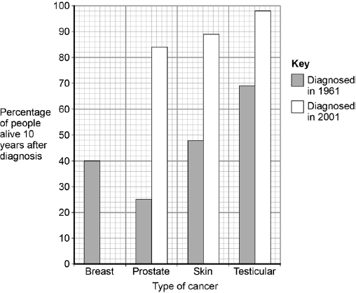

78% of people diagnosed with breast cancer in 2001 were alive 10 years later.
Complete the figure above to show this information. (1)

(c) Which type of cancer diagnosed in 1961 had the highest survival rate? Tick one box.

Breast
Prostate
Skin
Testicular
(1)
(d) Which type of cancer shows the biggest improvement in the percentage of people alive after 10 years? Tick one box.

Breast
Prostate
Skin
Testicular
(1)
(g) Suggest two reasons why the survival rates for all cancers have increased.
1. _________________________________________________________________
___________________________________________________________________
2. _________________________________________________________________
___________________________________________________________________
(2)

Mark schemes
Task 1:
(a) mitosis
extra box ticked negates mark
1
(b) cell division is uncontrolled
extra box ticked negates mark
1

(c) (i) (as a result of) uncontrolled / abnormal growth / division of cells
ignore mutation
allow cells dividing with no contact inhibition
1
(ii) benign tumours do not invade / spread to other tissues / do not form secondary tumours
accept converse for malignant
accept benign tumours do not metastasise
1
(iii) cells can break off
allow cells invade other tissues
1
travel in blood
accept travel in lymph (fluid)
1
Task 2:
(a) any three from:
- smoking / tar
- alcohol
- carcinogens
- allow named chemical
- viruses (living in cells)
- Genes (genetic)
- (ionising) radiation
- accept UV / X-rays / gamma waves

1
(d) bar plotted at 78%
ignore width of bar
1
(e) testicular
extra box ticked negates mark
1
(f) prostate
extra box ticked negates mark
1

(g) any two from:
• improved treatment / drugs
• earlier diagnosis
• more cancer screening
• improved patient knowledge (of risk factors)
allow improved patient diet / lifestyle
2

