Science Home learning
Lesson Title: Organisation 12 Year:
Topic: Organisation Unit: Biology

Date Set:

Information to read / watch:
https://classroom.thenational.academy/lessons/heart-disease-61k68d
https://classroom.thenational.academy/lessons/cancer-c8rp8d
Application:
Please see the exam-style questions that accompany this sheet. You must complete the questions and then self-assess using the mark scheme that has been provided.

Additional Websites:
https://www.youtube.com/watch?v=VO2QkpwAG9o
https://www.youtube.com/watch?v=3CFsOAybTO8
Organisation – Lifestyle choices M.E. Time task

Objective: Students should be able to: • discuss the human and financial cost of these non-communicable diseases to an individual, a local community, a nation or globally • explain the effect of lifestyle factors including diet, alcohol and smoking on the incidence of non-communicable diseases at local, national and global levels. (WS 1.4)
Task 1: Obesity is a factor that affects Coronary Heart Disease (CHD).
(a) What is meant by obesity?
___________________________________________________________________
(1)
(b) The chart below is published by the British Heart Foundation. It shows how death from
CHD is related to a number of different factors.
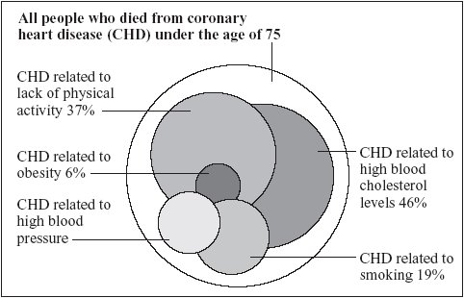
copyright National Heart Forum
Each factor is represented by a circle. The bigger the circle, the more people are affected by the factor.
Describe and explain what the human and financial implications linked to a person having CHD are for:
A Community?
_________________________________________________________________________
_________________________________________________________________________
_________________________________________________________________________
_________________________________________________________________________

(4)

Task 1 – Scaffolding:

Think about what happens to someone when they are ill.

Where do they go?

Who helps them?

Can they work?

What if they die?

When a person has a disease like CHD, it will cost them a tremendous amount of money as they seek for medical help. This may affect their families as it becomes a large financial burden.

Some countries (such as the UK) will provide healthcare for their own citizens, therefore the government could spend a lot of money. However, as the government spends a lot of money on a particular group of people, they will unfortunately have to neglect another group of people that may require support.

The government has to pay out a lot of money to support their own citizens. Rather than simply paying the fees for their medical procedures and drugs, they also have to try and support the patients by helping them find jobs that are suitable for them.

Objective: Students should be able to understand the principles of sampling as applied to scientific data in terms of risk factors. (MS 2d)
Task 2:
Smoking during pregnancy can lead to many issues including:
- Increased risk of miscarriage
- Increased risk of birth defects
- The birthweight of the baby is reduced

The bar chart shows that when mothers smoke more than ten cigarettes a day, the birthweight of their babies is reduced.
Suggest two additional pieces of information that would need to be collected before drawing firm conclusions about the effect of mothers smoking on the birthweight of babies.
_____________________________________________________________________________________________________________________________________________________________________________________________________________________________________________________________________________________________________________________________________________________________________________________________________________________________________________ (2)

Task 2 – Scaffolding:

The principles of sampling
Epidemiology is the study of the distribution and patterns of health and disease, in and across populations.
Scientists study the incidence of disease, using medical records, and use medical research to investigate causes of disease.
When investigating health and disease, and risk factors are involved, scientists can't study every person on the planet. Scientists must study samples.
Samples must be representative - they must reflect the population under study.
They cannot:
- focus on certain groups and ignore others
- be affected by bias (favours one side)

To obtain a representative sample:
- the study must be wide, and cover all groups in the population being studied
- the study must be random within these groups

Objective: Students should be able to translate information between graphical and numerical forms; and extract and interpret information from charts, graphs and tables in terms of risk factors. (MS 2c, 4a)
Task 3: Scientists investigated the effect of different factors on health.
(a) People who are not active may have health problems.
The graph shows the percentage of 16-year-olds in some countries who are not active.
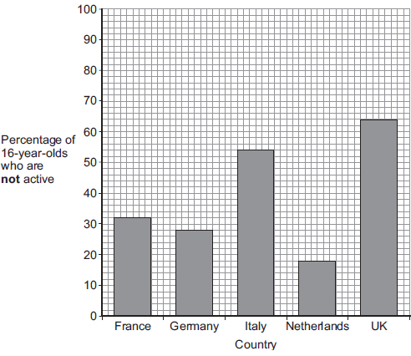
(i) What percentage of 16-year-olds in the UK are not active?
_____________ %
(1)
(ii) What percentage of 16-year-olds in the UK are active?
_____________ %
(1)
(iii) Suggest a health problem associated with not being active.
______________________________________________________________________
(1)

Objective: Students should be able to use a scatter diagram to identify a correlation between two variables in terms of risk factors. (MS 2g)
Task 4:

Using the graph above, describe the relationship between smoking and lung cancer.
__________________________________________________________________________________________________________________________________________________________________________________________________________________________________________________________________________________________________________________________________________________________________________________________________________________________________________________________________________________________________________ (2)

Mark schemes
Task 1
(a) being overweight
do not accept fat unqualified
allow BMI over 25
1
(b) Financial implications: (1)
Extra medication, Surgery, unable to work
Human implications: (1)
Relative / friend dies, unable to support family, depression.
Task 2.
- Carry out a similar study of mothers of different age groups to see if similar results could be obtained.
- Check to ensure that other factors - for instance, related to lifestyle factors of the experimental group - could not have affected birthweight.
Task 3:
(a) (i) 64
1
(ii) 36
allow e.c.f from (i) i.e. 100 − answer given in (a)(i)
1
(b) Obesity, CHD
Task 4:
More cigarettes smoked more likely to get lung cancer.
Males smoke more than females
Lung cancer more common in males who smoke.

