Science Home Learning
Lesson 3 – Magnetism Revision
Year: 11 | Topic: Physics
Unit: Magnetism & Electromagnetism | Date Set:
Information to read/watch:

Oak Academy:
https://classroom.thenational.academy/units/electricity-and-magnetism-ab64

Seneca:
https://app.senecalearning.com/classroom/course/fe56ca00-05aa-11e8-9a61-01927559cfd5/section/0fe18250-05ca-11e8-a9c0-bbcf210a0d3d/session

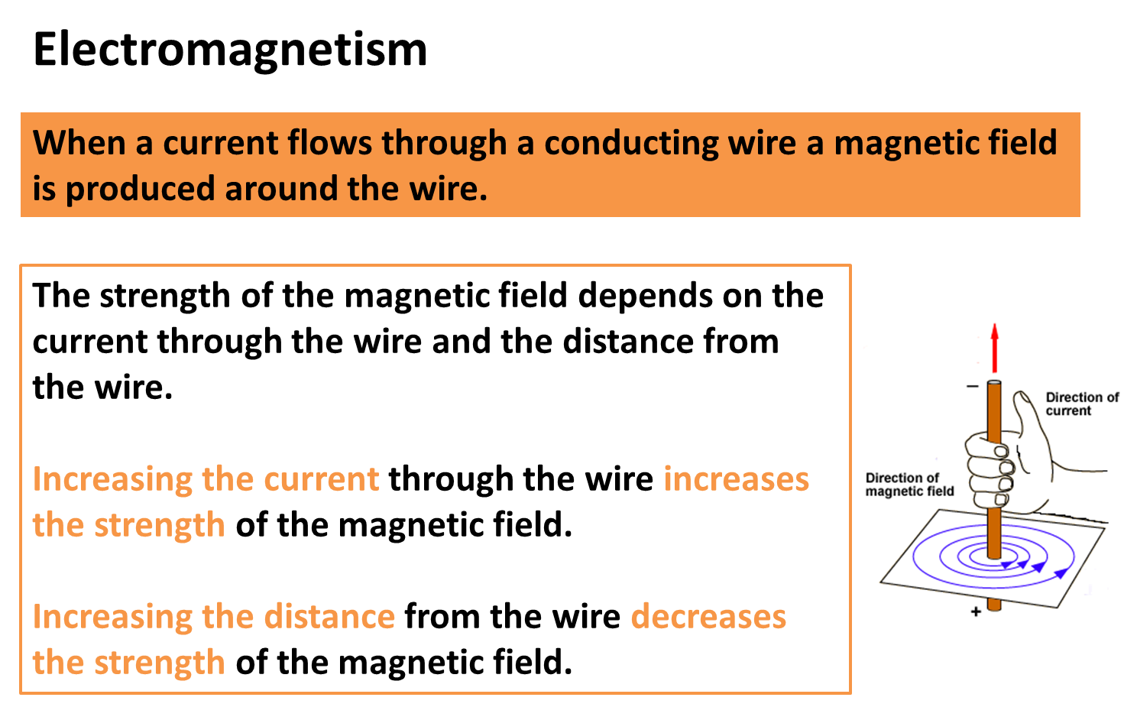

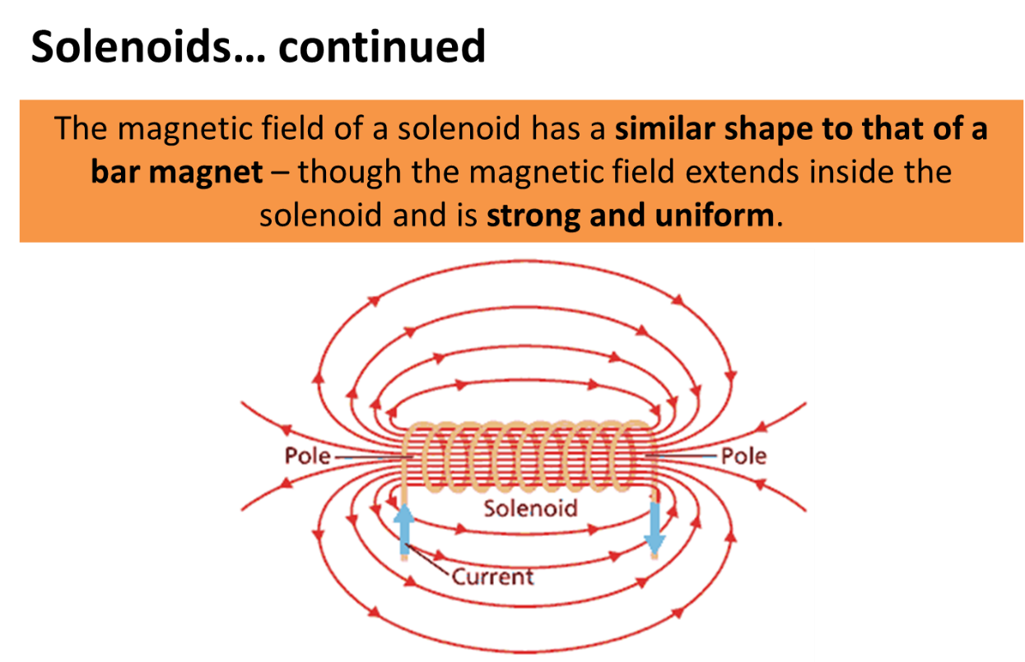

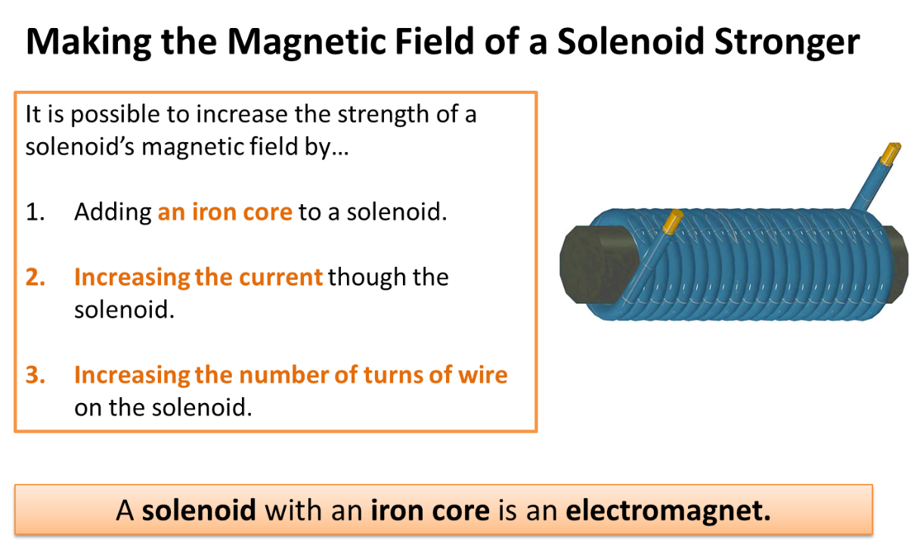

Tasks:
- What is produced when a current flows through a conducting wire?
- Name two factors which will impact on your answer to question 1.
- What is a solenoid?
- Describe the magnetic field inside a solenoid.
- State three ways of increasing the strength of the magnetic field produced by a solenoid.
- Draw the magnetic field pattern produced by a solenoid.
- What is an electromagnet?

Additional Websites:
https://youtu.be/SCnGfE7qxHc
Magnetism and electromagnetism - GCSE Science Revision - AQA Trilogy - BBC Bitesize

Answers:
- What is produced when a current flows through a conducting wire?
Magnetic field.
- Name two factors which will impact on your answer to question 1.
Current flowing through the wire, distance from the wire.
- What is a solenoid?
Coil of wire in which a magnetic field is created by passing a current though it.
- Describe the magnetic field inside a solenoid.
Strong and uniform.
- State three ways of increasing the strength of the magnetic field produced by a solenoid.
Increase the current
- Draw the magnetic field pattern produced by a solenoid.

- What is an electromagnet?
Solenoid with an iron core.

