Science Home learning
We hope you are all doing well at home, well done for doing your science work :-). Below are the email addresses for all Science staff. Do not hesitate to contact any of us with any questions. We even have twitter!
Jamie.venning@astreadearne.org, Thomas.bagnall@astreadearne.org, Danie.cadman@astreadearne.org, sean.guy@astreadearne.org, Kayleigh.smith@astreadearne.org, Robert.gray@astreadearne.org, Vicky.conway@astreadearne.org, dawn.brough@astreadearne.org, Hannah.szabo@astreadearne.org, Richard.white@astreadearne.org, victor.oczadly@astreadearne.org, Twitter Link: @Dearnescienc
Lesson 3 – Energy Changes Revision 01
Year: 10 Topic: Chemistry
Unit: Energy Changes Date Set:

Information to read / watch:
https://www.youtube.com/watch?v=L7829UGifpM

The Whole of AQA –Energy Changes GCSE Chemistry or Combined Science Revision

Tasks:
Complete ME time tasks below

Extension: Extension Task
Additional Websites:
https://www.bbc.co.uk/bitesize/topics/z27xxfr

Energy Changes Revision lesson 01 ME TIME TASK
Q1.
This question is about compounds of oxygen.
The reaction between carbon and oxygen is exothermic.
(a) What does exothermic reaction mean?
___________________________________________________________________
___________________________________________________________________
(1)
(b) Which is the correct reaction profile (energy level diagram) for an exothermic reaction?
Tick one box.

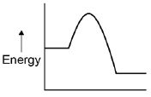
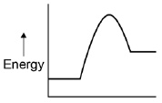
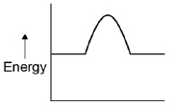
(1)

(c) The percentage by mass of oxygen in carbon dioxide (CO₂) is calculated by the equation:
Relative atomic masses (A_{r}): C = 12 O = 16
Calculate the percentage by mass of oxygen in carbon dioxide (CO₂).
___________________________________________________________________
___________________________________________________________________
___________________________________________________________________
___________________________________________________________________
___________________________________________________________________
___________________________________________________________________
___________________________________________________________________
Percentage by mass of oxygen = ____________________ %
(3)
Hydrogen peroxide decomposes to produce water and oxygen.
(d) Balance the chemical equation.
____ H₂O₂ → ____H₂O + O₂
(1)
(e) 6.8 g of hydrogen peroxide decomposes to produce 3.6 g of water.
Calculate the mass of oxygen produced when 68 g of hydrogen peroxide decomposes.
___________________________________________________________________
___________________________________________________________________
___________________________________________________________________
___________________________________________________________________
Mass of oxygen = ____________________ g
(2)
(Total 8 marks)

Q2.
This question is about the elements in Group 2 of the periodic table.
(a) Figure 1 shows the positions of four elements, A, B, C, and D, in the periodic table.
Figure 1
Which element is in Group 2?
Tick one box.

A |  | B |  | C |  | D
(1)
Group 2 metal carbonates break down when heated to produce a metal oxide and a gas.
metal carbonate ⟶ metal oxide + gas
(b) Name the two products when calcium carbonate (CaCO₃) is heated.
_______________________ and _______________________
(2)
(c) What type of reaction happens when a compound breaks down?
Tick one box.

burning
decomposition
neutralisation
reduction
(1)

(d) The metal carbonate takes in energy from the surroundings to break down.
What type of reaction takes in energy from the surroundings?
Tick one box.

combustion
electrolysis
endothermic
exothermic
(1)
(e) Figure 2 shows the volume of gas produced when a Group 2 metal carbonate is heated.
Figure 2
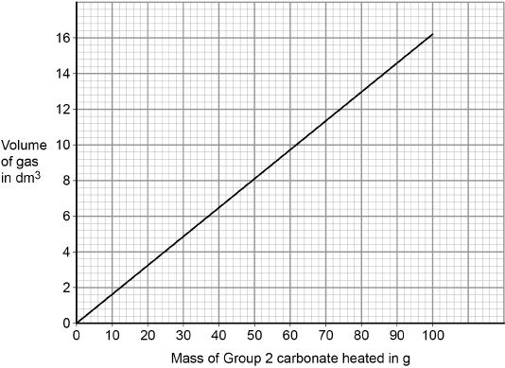
The student collected 5.2 dm³ of gas.
What mass of the Group 2 metal carbonate is heated?
Mass = ______________________ g
(1)

(f) Calculate the mass of the Group 2 carbonate needed to produce 24 dm³ of gas.
Use your answer from part (e) to help you.
___________________________________________________________________
___________________________________________________________________
___________________________________________________________________
___________________________________________________________________
Mass = ______________________ g
(2)
(g) A student heated different masses of a Group 2 carbonate. The student measured the volume of gas produced.
Figure 3 shows a graph of the student’s results.
The student calculates the gradient of the line in Figure 3
The student makes two mistakes.
Figure 3
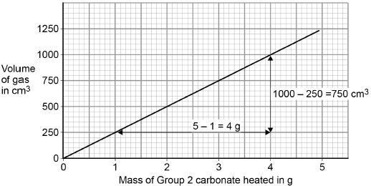
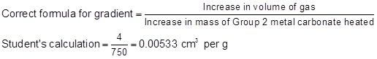
Identify the two mistakes the student makes.
Calculate the correct gradient of the line.
Mistake 1 ___________________________________________________________
___________________________________________________________________
Mistake 2 ___________________________________________________________
___________________________________________________________________
Calculation _________________________________________________________
___________________________________________________________________
Gradient = ______________________ cm³ per g
(4)
(h) A student repeated the experiment with a different Group 2 metal carbonate (XCO₃).
The relative formula mass (M_{r}) of XCO₃ is 84
Relative atomic masses (A_{r}): C = 12 O = 16
Calculate the relative atomic mass (A_{r}) of X.
Name metal X.
Use the periodic table.
___________________________________________________________________
___________________________________________________________________
___________________________________________________________________
___________________________________________________________________
Relative atomic mass (A_{r}) = ______________________
Metal X is ______________________
(4)
(Total 16 marks)

Q3.
(c) The equation shows the reaction of methane with oxygen.
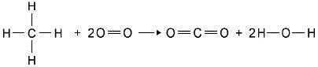
The table shows the bond energies.

Bond | C–H | O=O | C=O | O–H
Bond dissociation energy in kJ per mole | 412 | 496 | 803 | 463
Calculate the overall energy change for the combustion of one mole of methane.
___________________________________________________________________
___________________________________________________________________
___________________________________________________________________
___________________________________________________________________
___________________________________________________________________
___________________________________________________________________
___________________________________________________________________
___________________________________________________________________
Energy change = ____________________ kJ mol^{–1}
(3)
(Total 9 marks)

Challenge TASK

Exothermic reactions transfer energy to the surroundings.
(a) Draw a reaction profile for an exothermic reaction using the axes in Figure 1.
Show the:
• relative energies of the reactants and products
• activation energy and overall energy change.
Figure 1
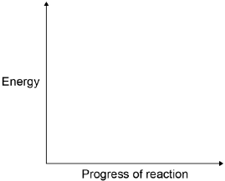
(2)

(b) Combustion is an exothermic reaction.
Calculate the overall energy change for the complete combustion of one mole of methane in oxygen.
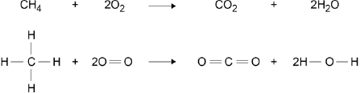

Bond | Bond energy in kJ / mol
 | 413
 | 498
 | 805
 | 464

___________________________________________________________________
___________________________________________________________________
___________________________________________________________________
___________________________________________________________________
___________________________________________________________________
___________________________________________________________________
Overall energy change = __________________ kJ / mol
(3)
(c) Figure 2 shows the chemicals given to a student.
Figure 2
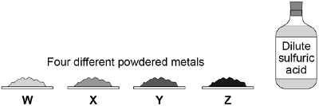
The student wants to investigate the reactivity of the four metals.
Outline a plan the student could use to investigate the relative reactivity of the four metals, W, X, Y and Z.
The plan should use the fact that all four metals react exothermically with dilute sulfuric acid.
You should name the apparatus used and comment on the safe use of the chemicals.
___________________________________________________________________
___________________________________________________________________
___________________________________________________________________
___________________________________________________________________
___________________________________________________________________
___________________________________________________________________
___________________________________________________________________
___________________________________________________________________
___________________________________________________________________
___________________________________________________________________
(6)
(d) Another student used displacement reactions to investigate the relative reactivity of the four metals, W, X, Y and Z.
The table below shows the student’s results.

 | Observations
Solution | Metal W | Metal X | Metal Y | Metal Z
Copper nitrate | Brown layer formed on metal | Brown layer formed on metal | Brown layer formed on metal | No change
Magnesium sulfate | No change | No change | No change | No change
Sulfuric acid | Gas bubbles produced | Few gas bubbles produced | Gas bubbles produced | No change
Zinc chloride | Grey layer formed on metal | No change | No change | No change
Give the order of reactivity of metals, W, X, Y and Z.
Use the results in the table above to justify your answer.
___________________________________________________________________
___________________________________________________________________
___________________________________________________________________
___________________________________________________________________
(3)

(e) The student concluded that these results could also be used to justify the order of reactivity of copper, magnesium, hydrogen and zinc.
The student is not completely correct. Use the results in the table above to explain why.
Suggest one further experiment that would provide evidence for the student’s conclusion.
___________________________________________________________________
___________________________________________________________________
___________________________________________________________________
___________________________________________________________________
___________________________________________________________________
___________________________________________________________________
___________________________________________________________________
___________________________________________________________________
___________________________________________________________________
___________________________________________________________________
(4)
(Total 18 marks)

Mark schemes
Q1.
(a) (a reaction that) transfers energy to the surroundings
1
(b) 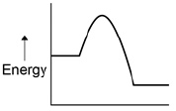
1
(c) 2 × 16 (= 32)
1
(M_{r} =) 44
1
72.7 (%)
1
(d) 2 2
allow multiples
1
(e) 3.2 g of O₂ produced from 6.8 g of H₂O₂
1
32 (g)
1
[8]
Q2.

(b) calcium oxide or CaO
1
carbon dioxide or CO₂
1
either order
(c) decomposition
1
(d) endothermic
1
(e) 32 (g)
allow 31−33 (g)
1
(f) 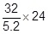
1
148 (g)
allow a range 143−153 (g)
or
uses graph e.g. 12 dm³ gives 74 (g) (1)
(then factors up so that 24 dm³ gives) 148 (g) (1)
allow a range 143−153 (g)
1
an answer of 148 (g) scores 2 marks
allow ecf from part (e)
(g) (mistakes)
increase in mass = 3 (not 4)
allow mistakes in either order
1
inserted numbers inversely into formula
allow numbers wrong way round
1
(calculation)
an answer of 250 scores the 2 calculation marks
1
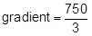
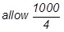
250 (cm³ per g)
if no calculation marks awarded
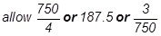
or 0.004 for 1 mark
1
(h) 3 × 16 or 48
1
(48) + 12 or 60
allow their mass of oxygen + 12
1
84 − (60) or 24
allow 84 − their mass of carbonate
1
magnesium or Mg
magnesium or Mg without working scores this mark
1
an answer of 24 scores the 3 calculation marks
[16]
Q3.
(a)
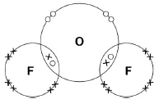
two shared pair of electrons
all outer shells complete
1
1
(b) gas
1
small molecules
1
(with) intermolecular forces
1
(so require) little energy to overcome
1
(c) calculates sum of all bonds broken:
4× (C–H) + 2× (O=O) = (4×412) + (2×496) = 2640
1
calculates sum of all bonds made:
4× (O–H) + 2(C=O) = (4×463) + (2×803) = 3458
1
overall energy change =
bonds broken – bonds made =
2640 – 3458 = (–)818
1
[9]

Challenge Task
(a) the relative energies of the reactants, products and the overall energy change
1
the activation energy
1
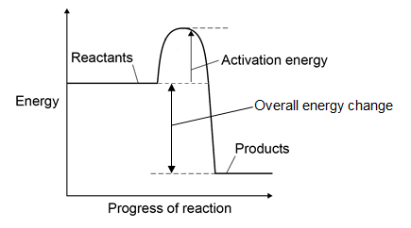
(b) (4 × 413) + (2 × 498) = 2 648
1
(2 × 805) + (4 × 464) = 3 466
1
(3466 − 2648 =) 818 (kJ / mol)
1
allow max 2 marks for one ecf
(c) Level 3 (5–6 marks):
A coherent method is described with relevant detail, which demonstrates a broad understanding of the relevant scientific techniques and procedures. The steps in the
method are logically ordered with the dependent and control variables correctly identified. The method would lead to the production of valid results.
Level 2 (3–4 marks):
The bulk of a method is described with mostly relevant detail, which demonstrates a reasonable understanding of the relevant scientific techniques and procedures. The
method may not be in a completely logical sequence and may be missing some detail.
Level 1 (1–2 marks):
Simple statements are made which demonstrate some understanding of some of the relevant scientific techniques and procedures. The response may lack a logical structure and would not lead to the production of valid results.
0 marks:
No relevant content
Indicative content

Named apparatus
• thermometer
• measuring cylinder
• stirring rod
• spatula
• plastic cup (with lid) or beaker
• stopwatch
• filter paper or watch glass
• balance
Method
• weigh the same mass of each metal in each same state of division eg
powder
• measure a set volume of sulfuric acid into a plastic cup or beaker
• measure and record the temperature of the sulfuric acid
• add metal W into the plastic cup or beaker
• stir and record the highest temperature or record the temperature after a set time
• calculate the increase in temperature
• repeat the method for metals X, Y and Z
• repeat for each metal at least three times to calculate a mean
Safe use
• comment on safe use should include wearing safety glasses
6
(d) W>Y>X>Z
1
reason for position of W and Z
W reacts with most solutions whereas Z reacts with none of the solutions
1
reason for position of X and Y
Y is more reactive than X because Y reacts more with sulfuric acid
1
(e) magnesium is most reactive because not displaced by any metal
1
zinc is second most reactive because displaced by only one metal
1
copper and hydrogen cannot be placed in order of reactivity or are least reactive because
1
they both are displaced by the most / three metals
1
experiment – add sulfuric acid to copper because copper is less reactive than hydrogen
then copper would not react with sulfuric acid to displace hydrogen
1
[19]

