Additional Revision Information Document
Topic Title: Energy (Physics)
Topic Reference: Paper 2 Revision
Key information:
Energy Stores and systems
A system is an object or group of objects.
There are changes in the way energy is stored when a system changes.

Changes in energy
The kinetic energy of a moving object can be calculated using the equation:

kinetic energy, Ek, in joules, J mass, m, in kilograms, kg speed, v, in metres per second, m/s

The amount of elastic potential energy stored in a stretched spring can be calculated using the equation:

Elastic potential energy, Ee, in joules, J spring constant, k, in newtons per metre, N/m extension, e, in metres, m

The amount of gravitational potential energy gained by an object raised above ground level can be calculated using the equation:

Gravitational potential energy, Ep, in joules, J mass, m, in kilograms, kg gravitational field strength, g, in newtons per kilogram, N/kg (In any calculation the value of the gravitational field strength (g) will be given). height, h, in metres, m.

Energy changes in systems
The amount of energy stored in or released from a system as its temperature changes can be calculated using the equation:

change in thermal energy, ∆E, in joules, J mass, m, in kilograms, kg specific heat capacity, c, in joules per kilogram per degree Celsius, J/kg °C temperature change, ∆θ, in degrees Celsius, °C

The specific heat capacity of a substance is the amount of energy required to raise the temperature of one kilogram of the substance by one degree Celsius.

Power
Power is defined as the rate at which energy is transferred or the rate at which work is done.

Power, P, in watts, W energy transferred, E, in joules, J time, t, in seconds, s work done, W, in joules, J
An energy transfer of 1 joule per second is equal to a power of 1 watt.

Energy transfers in a system
Energy can be transferred usefully, stored or dissipated, but cannot be created or destroyed.

Efficiency
The energy efficiency for any energy transfer can be calculated using the equation:

National and global energy resources
The main energy resources available for use on Earth include: fossil fuels (coal, oil and gas), nuclear fuel, bio-fuel, wind, hydroelectricity, geothermal, the tides, the Sun and water waves. A renewable energy resource is one that is being (or can be) replenished as it is used. The uses of energy resources include: transport, electricity generation and heating.

Media | LINK
Oak National Academy | https://classroom.thenational.academy/units/energy-ft-009a  (Foundation)  https://classroom.thenational.academy/units/energy-ht-265e  (Higher)  https://classroom.thenational.academy/units/energy-c750  (Physics only)
YouTube Clips | https://www.youtube.com/watch?v=L7829UGifpM  https://www.youtube.com/watch?v=eAZ_fn2Tsmw
GCSE Pod | https://members.gcsepod.com/shared/podcasts/title/10962
BBC Bitesize | https://www.bbc.co.uk/bitesize/topics/z34kgdm
Addition Website | https://www.youtube.com/watch?v=PQtjfRolMAE

Q1.
A teacher demonstrated the temperature change when hydrochloric acid is added to sodium hydroxide.
This is the method used.
1. Add 25.0 cm³ of sodium hydroxide solution to a polystyrene cup.
2. Measure the temperature of the sodium hydroxide solution.
3. Add 25.0 cm³ of hydrochloric acid to the sodium hydroxide solution.
4. Stir the solution.
5. Measure the maximum temperature of the solution.
(a) Draw one line from each measurement to the most suitable piece of equipment to use to make the measurement.

Measurement |  | Equipment
 |  | balance
Temperature of solution |  | beaker
 |  | measuring cylinder
Volume of hydrochloric acid |  | metre rule
 |  | thermometer
(2)

(b) The teacher did the experiment four times.
The table below shows the teacher’s results.

Experiment | Maximum temperature rise in °C
1 | 6.1
2 | 7.8
3 | 6.1
4 | 6.4
Calculate the mean maximum temperature rise.
Do not use the anomalous result in your calculation.
___________________________________________________________________
___________________________________________________________________
___________________________________________________________________
___________________________________________________________________
Mean maximum temperature rise = _______________ °C
(2)
(c) How could the accuracy of the experiment be improved?
Tick one box.

Add 20.0 cm³ of hydrochloric acid
Use a lid on the polystyrene cup
Use a metal beaker
Use a thermometer with a resolution of 1 °C
(1)
The reaction between hydrochloric acid and sodium hydroxide is a neutralisation reaction.
The reaction produces a salt and one other product.
(d) Complete the word equation for the reaction.
hydrochloric acid + sodium hydroxide ⟶ ____________________ + ____________
(2)

(e) Universal indicator is used to measure the pH of solutions.
Hydrochloric acid is pH 1
Sodium hydroxide is pH 13
Draw one line from the pH to the colour of universal indicator in a solution with that pH.

pH |  | Colour of universal indicator
 |  | green
1 |  | orange
 |  | purple
13 |  | red
 |  | yellow
(2)
(Total 9 marks)
Q2.
This question is about temperature changes.
(a) A student investigated the temperature change when 8 g of sodium nitrate dissolves in 50 cm³ of water.
The diagram below shows the apparatus the student used.
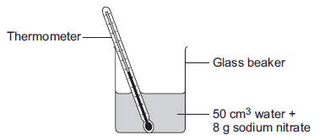

The student did the experiment five times.
Table 1 shows the results.

Table 1
Experiment | Decrease in temperature of water in °C
1 | 5.9
2 | 5.7
3 | 7.2
4 | 5.6
5 | 5.8
(i) Calculate the mean decrease in temperature.
Do not use the anomalous result in your calculation.
______________________________________________________________
______________________________________________________________
Mean decrease in temperature = ___________________ °C
(2)
(ii) Suggest one change in the apparatus in the diagram above which would improve the accuracy of the results.
Give a reason for your answer.
______________________________________________________________
______________________________________________________________
______________________________________________________________
______________________________________________________________
(2)

(b) The student investigated the temperature change when different masses of sodium carbonate were added to 50 cm³ of water at 20 °C.
Table 2 below shows the results.

Table 2
Mass of sodium carbonate in g | Final temperature of solution in °C
2.0 | 21.5
4.0 | 23.0
6.0 | 24.5
8.0 | 26.0
10.0 | 26.6
12.0 | 26.6
14.0 | 26.6
Describe the relationship between the mass of sodium carbonate added and the final temperature of the solution.
Use values from Table 2 in your answer.
___________________________________________________________________
___________________________________________________________________
___________________________________________________________________
___________________________________________________________________
___________________________________________________________________
___________________________________________________________________
(3)
(Total 7 marks)

Q3.
A student investigates the energy released when hydrochloric acid completely neutralises sodium hydroxide solution.
The student uses the apparatus shown in Figure 1.
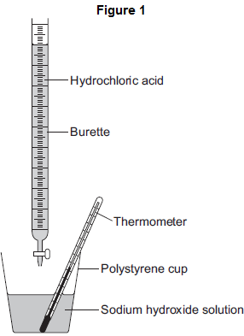
The student:
• measures 25 cm³ sodium hydroxide solution into a polystyrene cup
• fills a burette with hydrochloric acid
• measures the temperature of the sodium hydroxide solution
• adds 5 cm³ hydrochloric acid to the sodium hydroxide solution in the polystyrene cup
• stirs the mixture and measures the highest temperature of the mixture
• continues to add 5 cm³ portions of hydrochloric acid, stirring and measuring the highest temperature of the mixture after each addition.
(a) The student has plotted a graph of the results.
The graph line has been incorrectly drawn by including an anomalous result.
The graph is shown in Figure 2.
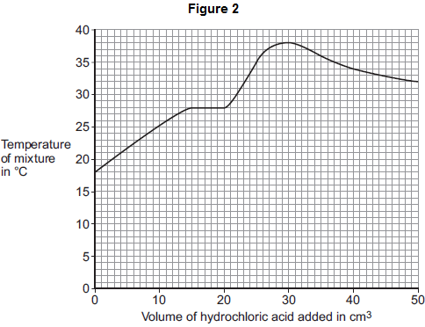
(i) Suggest a cause for the anomalous result when 20 cm³ of hydrochloric acid is added.
______________________________________________________________
______________________________________________________________
(1)
(ii) Suggest the true value of the temperature of the anomalous point.
Temperature = _______________ °C
(1)
(iii) What was the total volume of the mixture when the maximum temperature was reached?
______________________________________________________________
Total volume of the mixture = _______________ cm³
(1)
(iv) Calculate the overall temperature increase in this experiment.
______________________________________________________________
Overall temperature increase = _______________ °C
(1)

(v) Use your answers to (iii) and (iv) and the equation to calculate the energy released in the reaction. Give the unit.
Assume the volume in cm³ is equivalent to the mass of solution in grams.
Equation: Q = mcΔT
where:
Q = energy released
m = mass of solution (g)
c = 4.2 (J per g per °C)
ΔT = change in temperature (°C)
______________________________________________________________
______________________________________________________________
Energy released = _______________ Unit = __________
(2)
(b) The student did the experiment again, starting with 50 cm³ of sodium hydroxide solution instead of 25 cm³.
Explain why this would make no difference to the overall temperature increase.
___________________________________________________________________
___________________________________________________________________
___________________________________________________________________
___________________________________________________________________
(2)
(Total 8 marks)

Mark schemes
Q1.
(a)
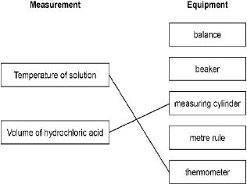
1
1
(b) 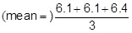
1
= 6.2 (°C)
allow an answer of 6.6 (°C) for 1 mark
1
an answer of 6.2 (°C) scores 2 marks
(c) use a lid on the polystyrene cup
1
(d) sodium chloride
allow NaCl
1
water
allow H₂O
1

(e)
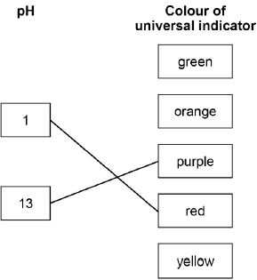
1
1
[9]
Q2.
(a) (i) 5.75 or 5.8
correct answer with or without working gains 2 marks
correct working showing addition of any four results and division by 4 gains 1 mark
OR
6(.04) for 1 mark
2
(ii) use a polystyrene cup or lid
accept insulate the beaker
1
to prevent energy/heat gain
accept to prevent energy/heat transfer
do not accept energy/heat loss
OR
use a digital thermometer
allow use a data logger
easier to read (to 0.1°C)
1

(b) (as mass increases) the final temperature increases
1
then stays constant
1
correct reference to a value above 8 g up to and including 10 g as mass when the trend changes
1
[7]
Q3.
(a) (i) any one from:
• incorrect measurement of temperature or volume
• incorrect recording of temperature
• failure to stir
• heat loss
ignore faulty equipment
1
(ii) 32 - 33
1
(iii) 55
1
(iv) 20
1
(v) 4620
allow 4.62 kJ for 2 marks
1
J / joules
allow kJ if evidence of dividing by 1000
mark independently, but if a numerical answer has been divided by 1000 must be kJ.
allow ecf from their answers to (iii) and (iv)
1
(b) twice as much energy released
1
but twice as much water to heat
allow more energy released but more water to heat for 2 marks
if no other mark awarded, allow twice the amount of hydrochloric acid used for 1 mark
1
[8]

