Science Home learning
We hope you are all doing well at home, well done for doing your science work :-). Below are the email addresses for all Science staff. Do not hesitate to contact any of us with any questions. We even have twitter!
Jamie.venning@astreadearne.org, Thomas.bagnall@astreadearne.org, Danie.cadman@astreadearne.org, sean.guy@astreadearne.org, Kayleigh.smith@astreadearne.org, Robert.gray@astreadearne.org, Vicky.conway@astreadearne.org, dawn.brough@astreadearne.org, Hannah.szabo@astreadearne.org, Richard.white@astreadearne.org, victor.oczadly@astreadearne.org, Twitter Link: @Dearnescience
L13 Quantitative Chemistry Revision - Equations
Year: 10 Topic: Chemistry
Unit: Quantitative Chemistry Date Set:

Information to read / watch:
https://www.youtube.com/watch?v=eAibVvhmsK0
The Whole of AQA -QUANTITATIVE CHEMISTRY. GCSE Chemistry or Combined Science Revision Topic 3 for C1.
Objectives:
Be able to recall the relevant equations for the topic and identify where they are used.

Use the information from the video to complete the table on the next page.
Once you have completed the sheet. Click on the link below and attempt the questions.
https://www.youtube.com/watch?v=8uqWdmIKd7c

Additional Websites/ resources:
See help sheet after the table, which gives worked examples for each of the calculations.

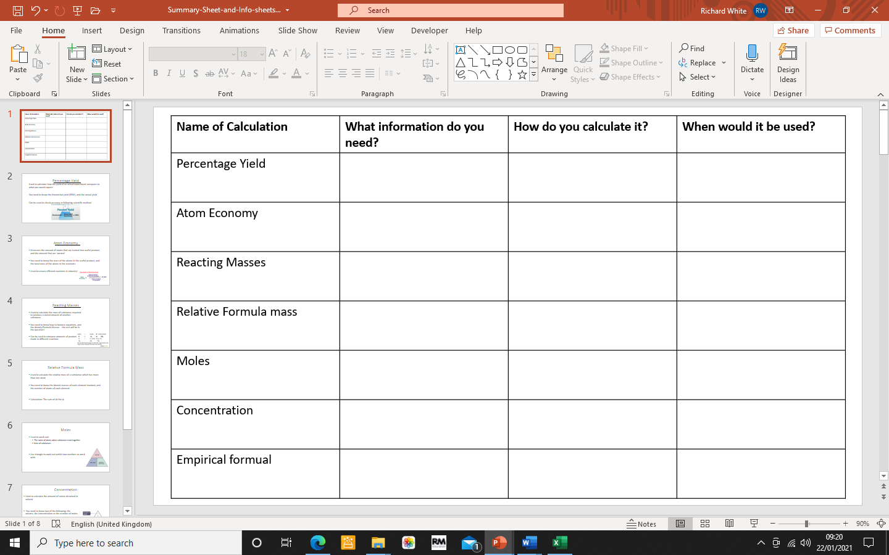
CHEMISTRY: HOW MUCH (CALCULATIONS)
Relative Formula Mass (M_{r})
To find the relative formula mass of a compound you add up the relative atomic masses of all the atoms in the compound.
e.g. MgSO₄ contains:
1 x Mg: 1 x 24 = 24
1 x S: 1 x 32 = 32
4 x O: 4 x 16 = 64
So the relative formula mass = 24 + 32 + 64 = 120

Moles
The relative formula mass of a substance in grams is known as ONE MOLE of that substance.
e.g. MgSO₄ Relative Formula Mass = 120
Mass of One Mole = 120grams
A mole of a substance always contains the same number of particles, just like a dozen of anything is always 12.

Calculating the Percentage Mass of an Element in a Compound
e.g. Find the mass of hydrogen in CH₄
- Write down the formula: CH₄

- Work out the relative formula mass:

C= 12
H= 1
H=1
H=1
H=1 relative formula mass = 12 + 1 + 1 +1 + 1 = 16

- Work out the mass of the element you are looking for in one formula unit (e.g. the amount of H in CH₄)

CH₄ : there are four hydrogens in the formula,
so the mass is 1 + 1 + 1 + 1 = 4 (1 is the atomic mass of hydrogen)

- Calculate the percentage of the element in formula

Mass of the element you are looking for x 100
The relative formula mass of the entire compound
4 x 100 = 25 %
16

Working Out the Formula of a Compound from Reacting Masses (or the EMPIRICAL formula)
e.g. A sample of a compound has 16g of sulfer and 24g of oxygen. Work out the formula of this compound.
It is easiest to do this in a table:
- Write the name of the elements at the top of the table
Sulfur | Oxygen

- Write the amount you have of each element
Sulfur | Oxygen
16g | 24g
- Work out how many moles of the each element you have by dividing them by the RELATIVE ATOMIC MASS
Atomic mass of oxygen = 16
Atomic mass of Sulfer = 32
Sulfur | Oxygen
16g | 24g
16 ÷ 32 = 0.5 | 24 ÷ 16 = 1.5
- Divide by the smallest to find a RATIO
0.5 is smaller than 1.5, so we divide them both by 0.5
Sulfur | Oxygen
16g | 24g
16 ÷ 32 = 0.5 | 24 ÷ 16 = 1.5
0.5 ÷ 0.5 = 1 | 1.5 ÷ 0.5 = 3

- Use the RATIO to work out the formula as it tells you how many of each element you have
Sulfur | Oxygen
16g | 24g
16 ÷ 32 = 0.5 | 24 ÷ 16 = 1.5
0.5 ÷ 0.5 = 1 | 1.5 ÷ 0.5 = 3
One sulfer | Three oxygens

The formula has one sulfer and three oxygens so looks like:
SO₃
Working out the Mass of a Reactant or Product Using the Formula
You will be given the mass of one of the reactants/ products and be expected to use to find the mass of another using the formula.
e.g. What mass of carbon will react exactly with 40g of copper oxide. Work out using the formula:
2CuO + C → 2Cu + CO₂
- Work out the RATIO of the reactants and products by looking at the numbers in front of the compounds. If there is no number then we assume it is one.
2CuO + C → 2Cu + CO₂

2 : 1 : 2 : 1
- Covert the mass of the compound you are given (the 40g of CuO) by dividing the mass by the relative formula mass of the compound
Relative formula mass of CuO:
1 x Cu: 1 x 64 = 64
1 x O: 1 x 16 = 16 relative formula mass = 64 + 16 = 80

Mass given = 40 = 0.5 moles of CuO
Relative formula mass 80

- Look at the RATIO to work out how many moles of CuO react with C (which your trying to find)
Ratio = 2 (CuO) : 1 (C)
Looking at this we can see that there are half the number of moles of C than CuO (2 divided by 2 is 1) so we need to half the number of moles of CuO that there are:
0.5 ÷ 2 = 0.25 mole of C

- Convert the number of moles of C to grams by multiplying the number of moles (0.25) by the atomic (formula if a compound) mass of C.
Atomic mass of C = 12
0.25 x 12 = 3g
Therefore there are 3g of carbon
Percentage Yield
The amount of product made in a reaction is called its yield.
The percentage yield tells us the amount of product made compared to the maximum amount that could be made.
e.g. Using known masses if A and B it was calculated that the chemical reaction could produce 200g of product, C. When the reaction was carried out only 140g of C is produced.
What is the percentage yield?
Percentage = amount of product actually produced x 100%
yield Maximum amount of product that could be produced

140 x 100% = 70%
200

Atom Economy

Atom economy is a measure of how much of the starting material ends up as USEFUL products.

e.g. CaCO₃ → CaO + CO₂
This reaction is used to produce calcium oxide (CaO). What is the atom economy of this reaction?

Atom economy = relative formula mass of useful products x 100%
Relative formula mass of all products

- Work out the relative formula mass of the useful product (the useful product is the one that the reaction is designed to produce, so in this case CaO)

Relative formula mass of CaO:

Ca: 1 x 40
O: 1 x 16 relative formula mass: 40 + 16 = 56

- Work out the relative formula mass of all the products

Work out the relative formula mass of the other product:

Relative formula mass of CO₂
C: 1 x 12
O₂: 2 x 16 = 32 relative formula mass = 32 + 12 = 44

Add up the relative formula masses of the products: CaO + CO₂ = 56 + 44 = 100

- Divide the relative formula mass of the useful products by the relative formula mass of all the products

56 = 0.56
100

- Multiply by 100%

0.56 x 100% = 56% atom economy

