Science Home learning
We hope you are all doing well at home, well done for doing your science work :-). Below are the email addresses for all Science staff. Do not hesitate to contact any of us with any questions. We even have twitter!
Jamie.venning@astreadearne.org, Thomas.bagnall@astreadearne.org, Danie.cadman@astreadearne.org, sean.guy@astreadearne.org, Kayleigh.smith@astreadearne.org, Robert.gray@astreadearne.org, Vicky.conway@astreadearne.org, dawn.brough@astreadearne.org, Hannah.szabo@astreadearne.org, Richard.white@astreadearne.org, victor.oczadly@astreadearne.org, Twitter Link: @Dearnescience
L11 Using concentrations of solutions in mol/dm³ Year: 10 (Triple only)
Topic: Chemistry Unit: Quantitative Chemistry
Date Set:

Information to read / watch:
https://www.youtube.com/watch?v=XCX0PkZdUjM
(Concentration calculations and formual | Chemical Calculations | Chemistry | FuseSchool)
https://www.youtube.com/watch?v=xsma3KjKPx8
(Free science lessons “Using concentrations of solutions 1”)
https://www.youtube.com/watch?v=Z93_atEmxNI
(Free science lessons “Using concentrations of solutions 2”)

Objectives:
Be able to explain how the concentration of a solution in mol/dm3 is related to the mass of the solute and the volume of the solution.

Explain the terms concentration and mol/dm3
Convert cm3 into dm3
Calculate the concentration of a solution.
Additional Websites:
https://www.bbc.co.uk/bitesize/guides/zgcyw6f/revision/4
Read the information on page 1
https://classroom.thenational.academy/units/quantitative-chemistry-4db7
Lesson 9 – Titration calculations
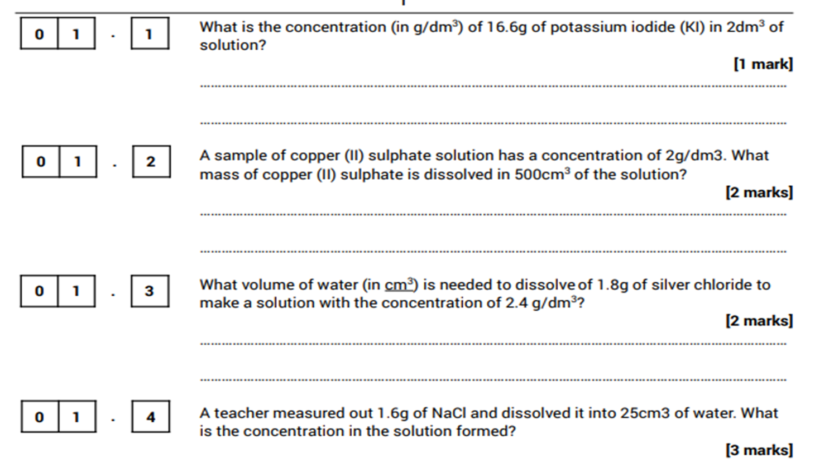

OR
Draw a table and fill in the gaps…
e.g.
A Student started with 30.0cm³ of sulphuric acid (H₂SO₄) of unknown concentration in a flask.
She found that it took on average 25cm³ of 0.100mol/dm³ sodium hydroxide (NaOH) to neutralise the sulphuric acid. Find the concentration of acid in mol/dm³.
The balanced symbol equation is:
2NaOH + H₂SO₄ → Na₂SO₄ + 2H₂O
Step 1: fill in the information you have
 | NaOH | H₂SO₄
Mol | ? | ?
Concentration (mol/dm³) | 0.100 | ?
Volume (dm³) | 0.025 | 0.03

Step 2: Calculate the moles of the solution where you have the concentration and the volume using mol = conc x vol.
0.1x0.025 = 0.0025 moles of NaOH (add this to your table)
 | NaOH | H₂SO₄
Mol | 0.0025 | ?
Concentration (mol/dm³) | 0.100 | ?
Volume (dm³) | 0.025 | 0.03
Step 3: The NaOH and H₂SO₄ are in a ratio of 2:1 (using the multiplier numbers from the equation). This means that the H₂SO₄ has half the number of moles that the NaOH does.
0.0025÷2=0.00125 moles of H₂SO₄ (add this to your table)
 | NaOH | H₂SO₄
Mol | 0.0025 | 0.00125
Concentration (mol/dm³) | 0.100 | ?
Volume (dm³) | 0.025 | 0.03

Step 4: Use your moles and volume of H₂SO₄ that you now have to calculate the concentration using the equation mol = conc x vol. (rearranged conc = mol ÷ vol)
0.00125 ÷ 0.03 = 0.0416 mol/dm³

 | NaOH | H₂SO₄
Mol | 0.0025 | 0.00125
Concentration (mol/dm³) | 0.100 | 0.0416
Volume (dm³) | 0.025 | 0.03

Q1.
This question is about acids and alkalis.
(a) Dilute hydrochloric acid is a strong acid.
Explain why an acid can be described as both strong and dilute.
___________________________________________________________________
___________________________________________________________________
___________________________________________________________________
___________________________________________________________________
(2)
(b) A 1.0 × 10⁻³ mol/dm³ solution of hydrochloric acid has a pH of 3.0
What is the pH of a 1.0 × 10⁻⁵ mol/dm³ solution of hydrochloric acid?
pH = ___________________
(1)
A student titrated 25.0 cm³ portions of dilute sulfuric acid with a 0.105 mol/dm³ sodium hydroxide solution.
(c) The table below shows the student’s results.

 | Titration  1 | Titration  2 | Titration  3 | Titration  4 | Titration  5
Volume of sodium hydroxide solution in cm³ | 23.50 | 21.10 | 22.10 | 22.15 | 22.15
The equation for the reaction is:
2 NaOH + H₂SO₄ ⟶ Na₂SO₄ + 2 H₂O
Calculate the concentration of the sulfuric acid in mol/dm³
Use only the student’s concordant results.
Concordant results are those within 0.10 cm³ of each other.
___________________________________________________________________
___________________________________________________________________
___________________________________________________________________
___________________________________________________________________
___________________________________________________________________
___________________________________________________________________
___________________________________________________________________
___________________________________________________________________
___________________________________________________________________
___________________________________________________________________
Concentration of sulfuric acid = ___________________ mol/dm³
(5)
(d) Explain why the student should use a pipette to measure the dilute sulfuric acid and a burette to measure the sodium hydroxide solution.
___________________________________________________________________
___________________________________________________________________
___________________________________________________________________
___________________________________________________________________
(2)
(e) Calculate the mass of sodium hydroxide in 30.0 cm³ of a 0.105 mol/dm³ solution.
Relative formula mass (M_{r}): NaOH = 40
___________________________________________________________________
___________________________________________________________________
___________________________________________________________________
___________________________________________________________________
Mass of sodium hydroxide = ___________________ g
(2)
(Total 12 marks)
Q2.
Sodium hydroxide neutralises sulfuric acid.
The equation for the reaction is:
2NaOH + H₂SO₄ → Na₂SO₄ + 2H₂O
(a) Sulfuric acid is a strong acid.
What is meant by a strong acid?
___________________________________________________________________
___________________________________________________________________
___________________________________________________________________
(2)
(b) Write the ionic equation for this neutralisation reaction. Include state symbols.
___________________________________________________________________
(2)
(c) A student used a pipette to add 25.0 cm³ of sodium hydroxide of unknown concentration to a conical flask.
The student carried out a titration to find out the volume of 0.100 mol / dm³ sulfuric acid needed to neutralise the sodium hydroxide.
Describe how the student would complete the titration.
You should name a suitable indicator and give the colour change that would be seen.
___________________________________________________________________
___________________________________________________________________
___________________________________________________________________
___________________________________________________________________
___________________________________________________________________
___________________________________________________________________
___________________________________________________________________
___________________________________________________________________
___________________________________________________________________
___________________________________________________________________
(4)
(d) The student carried out five titrations. Her results are shown in the table below.

 | Titration 1 | Titration 2 | Titration 3 | Titration 4 | Titration 5
Volume of 0.100 mol / dm³ sulfuric acid in cm³ | 27.40 | 28.15 | 27.05 | 27.15 | 27.15
Concordant results are within 0.10 cm³ of each other.
Use the student’s concordant results to work out the mean volume of 0.100 mol / dm³ sulfuric acid added.
___________________________________________________________________
___________________________________________________________________
___________________________________________________________________
___________________________________________________________________
Mean volume = _____________________________ cm³
(2)
(e) The equation for the reaction is:
2NaOH + H₂SO₄ → Na₂SO₄ + 2H₂O
Calculate the concentration of the sodium hydroxide.
Give your answer to three significant figures.
___________________________________________________________________
___________________________________________________________________
___________________________________________________________________
___________________________________________________________________
___________________________________________________________________
___________________________________________________________________
___________________________________________________________________
Concentration = _______________________ mol / dm³
(4)
(f) The student did another experiment using 20 cm³ of sodium hydroxide solution with a concentration of 0.18 mol / dm³.
Relative formula mass (M_{r}) of NaOH = 40
Calculate the mass of sodium hydroxide in 20 cm³ of this solution.
___________________________________________________________________
___________________________________________________________________
___________________________________________________________________
___________________________________________________________________
Mass = ________________ g
(2)
(Total 16 marks)

Mark schemes
Q1.
(a) (strong because) completely ionised (in aqueous solution)
ignore pH
allow dissociated for ionised
do not accept hydrogen is ionising
do not accept H⁺ are ionised
1
(dilute because) small amount of acid per unit volume
ignore low concentration
1
(b) 5.0
allow 5
1
(c) (titre):
chooses titrations 3, 4, 5
1
average titre = 22.13 (cm³)
allow average titre = 22.13(3…) (cm³)
allow a correctly calculated average from an incorrect choice of titrations
1
(calculation):
(moles NaOH =
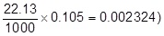
allow use of incorrect average titre from step 2
1
(moles H₂SO₄ =
½ × 0.002324 =) 0.001162
allow use of incorrect number of moles from step 3
1
(concentration =
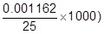
= 0.0465 (mol/dm³)
allow use of incorrect number of moles from step 4
1
alternative approach for step 3, step 4 and step 5
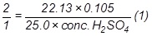
(concentration H₂SO₄ =)
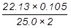
= 0.0465 (mol/dm³) (1)
an answer of 0.046473 or 0.04648 correctly rounded to at least 2 sig figs scores marking points 3, 4 and 5
an answer of 0.092946 or 0.09296 or 0.185892 or 0.18592 correctly rounded to at least 2 sig figs scores marking points 3 and 5
an incorrect answer for one step does not prevent allocation of marks for subsequent steps
(d) pipette measures a fixed volume (accurately)
1
(but) burette measures variable volume
allow can measure drop by drop
1
(e) 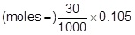
or 0.00315 (mol)
or
(mass per dm³ =) 0.105 × 40
or 4.2 (g)
1
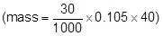
= 0.126 (g)
1
an answer of 0.126 (g) scores 2 marks
an answer of 126(g) scores 1 mark
an incorrect answer for one step does not prevent allocation of marks for subsequent steps
[12]
Q2.
(a) (sulfuric acid is) completely / fully ionised
1
In aqueous solution or when dissolved in water
1
(b) H⁺(aq) + OH⁻(aq) → H₂O(l)
allow multiples
1 mark for equation
1 mark for state symbols
2
(c) adds indicator, eg phenolpthalein / methyl orange / litmus added to the sodium hydroxide
(in the conical flask)
do not accept universal indicator
1
(adds the acid from a) burette
1
with swirling or dropwise towards the end point or until the indicator just changes colour
1
until the indicator changes from pink to colourless (for phenolphthalein) or yellow to red
(for methyl orange) or blue to red (for litmus)
1
(d) titrations 3, 4 and 5
or
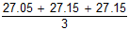
1
27.12 cm³
accept 27.12 with no working shown for 2 marks
1
allow 27.1166 with no working shown for 2 marks
(e) Moles H₂SO₄ = conc × vol = 0.00271
allow ecf from 8.4
1
Ratio H₂SO₄:NaOH is 1:2
or
Moles NaOH = Moles H₂SO₄ × 2 = 0.00542
1
Concentration NaOH = mol / vol = 0.00542 / 0.025 = 0.2168
1
0.217 (mol / dm³)
accept 0.217 with no working for 4 marks
1
accept 0.2168 with no working for 3 marks
(f) × 0.18 = no of moles
or
0.15 × 40 g
1
0.144 (g)
1
accept 0.144g with no working for 2 marks
[16]

