Science Home learning
We hope you are all doing well at home, well done for doing your science work :-). Below are the email addresses for all Science staff. Do not hesitate to contact any of us with any questions. We even have twitter!
Jamie.venning@astreadearne.org, Thomas.bagnall@astreadearne.org, Daniel.cadman@astreadearne.org, sean.guy@astreadearne.org, Kayleigh.smith@astreadearne.org, Robert.gray@astreadearne.org, Vicky.conway@astreadearne.org, dawn.brough@astreadearne.org, Hannah.szabo@astreadearne.org, Richard.white@astreadearne.org, victor.oczadly@astreadearne.org,
Twitter Link: @Dear
Lesson Title: The menstrual cycle Year: 8
Topic: Human reproduction Unit: Variation and human reproduction
Date Set: 25/01/2021

Information to read / watch:
Online lesson: https://classroom.thenational.academy/lessons/puberty-and-the-menstrual-cycle-ccw3ec?from_query=menstrual+cycle
Read: https://app.senecalearning.com/classroom/course/419c7523-d408-4bc7-9b96-f7f12abdacae/section/037b115a-7932-42be-a27e-d4ae87953522/session
Application:
Task 1: Define fertilisation
Task 2: Label the key events on the menstrual cycle timeline
Task 3: State where in the menstrual cycle pregnancy is most likely to occur. Justify your answer.
Challenge: Apply knowledge of the menstrual cycle to graphs showing the hormones involved
Misconceptions:
“The menstrual cycle is the same as a period” – The “period”, also known as menstruation, is only the beginning part of the menstrual cycle.
“All of the menstrual cycle hormones are made in the ovaries” – Oestrogen and progesterone are made in the ovaries, however FSH and LH are made in the pituitary gland.
“Only blood is lost during menstruation” – During menstruation, blood is lost, but so is the uterus lining, which breaks down if a fertilized egg has not been implanted.
Additional Websites:
https://www.bbc.co.uk/bitesize/guides/zcnp7p3/revision/2
https://www.bbc.co.uk/bitesize/guides/znxnscw/revision/3
Additional Information
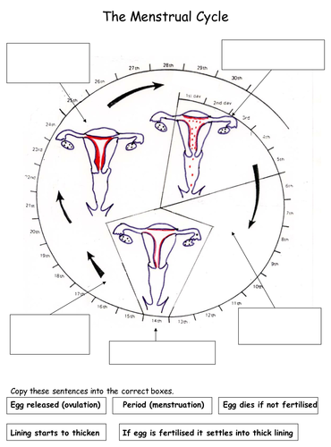
Task 2: Label the key events on the menstrual cycle diagram below:

Challenge: Use the information provided to answer the questions below:

The female menstrual cycle is controlled by a number of hormones. The graph below shows the concentrations of four of these hormones at different times during the menstrual cycle.

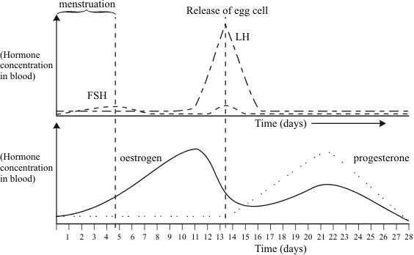

The functions of the four hormones include:

FSH – stimulates the development of immature cells into eggs in the ovary.

LH – stimulates the release of the mature egg cell.

Oestrogen – stimulates production of LH, but inhibits FSH production.

Progesterone – inhibits production of both LH and FSH.

Use this information to explain as fully as you can:

Task:
- State the order in which the four hormones are released during the menstrual cycle
- Which hormones are present when the egg is released. List answer starting with the hormone with highest concentration at the time.
- Suggest which two hormones could be used to prevent pregnancy, give a reason for your answer.

- Suggest which hormones could be used to increase the changes of pregnancy. give a reason for your answer.

