Week commencing 19/10/2020. Lesson 1: The Ghost of Christmas Past
Email all work to homelearning@astreadearne.org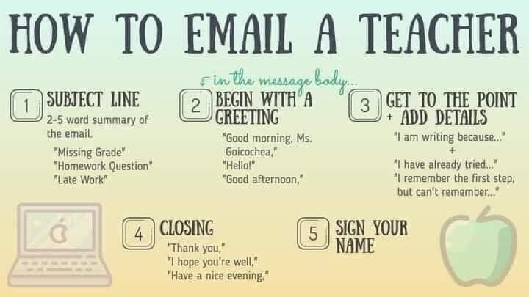

“It held a branch of fresh green holly in its hand; and … its dress trimmed with summer flowers”

Copy and label the sentence: noun, adjective, etc

Stretch: Why do you think the ghost is carrying holly and decorated in summer flowers?

Reclamation
= saving someone, like salvation

When Scrooge asks the Ghost why he is there, the Ghost says “your reclamation”.
- What does this hint (foreshadow) to us might happen later on in the novella?
- How does that make you feel as a reader?

Read Stave 2 of A Christmas Carol up to when the Ghost of Christmas Past asks Scrooge to “Rise! and walk with me!”

You can also listen to a reading of it here:

Sketch the Ghost of Christmas Past and label the drawing with quotations from the text.

Juxtaposition = two things placed close together with contrasting effect

Answer the questions in full sentences

- How does Dickens employ juxtaposition when describing the ghost? How is his appearance both youthful and aged?
- Why does Scrooge attempt to put out the light?
- Why can Scrooge not put out the light?
- What could the jet of light represent?

Myopia = the quality of short-sightedness

“Scrooge’s attempts to distinguish the ghost’s flame is down to his own ignorance and myopia: he does not want to change.”
How far do you agree?

