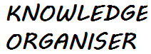
VIDEO(S): Collecting data:392-403, 872-873 displaying data: 422-432

MATHS

Unit: 8 Statistics-Y10/11 Athena
Key Vocabulary  1.Interpret  Explain the meaning of.  2.Information  Knowledge or facts  3. Popular  Widely liked and admired.  4. Record  Put in writing  5. Data  Information consisting of observations, measurements or facts.  6. Construct  Build or put together.  7. Symbol  A sign or thing that stands for something else.  8. Represent  Act as a delegate or substitute for 2. Stand for |  | WAGOLL  Complete a tally chart  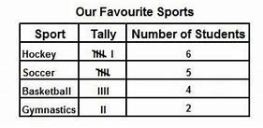  basketball hockey soccer hockey soccer gymnastics basketball soccer basketball soccer hockey gymnastics soccer hockey hockey basketball hockey  A tally chart uses marks to represents frequencies. These marks are ‘bunched’ into fives. Each l represents 1.  Represents 5.  Complete a pictogram  A pictogram uses a picture to represent frequency.  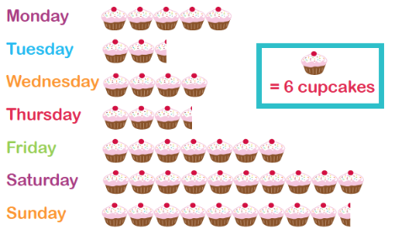  Construct a pie chart  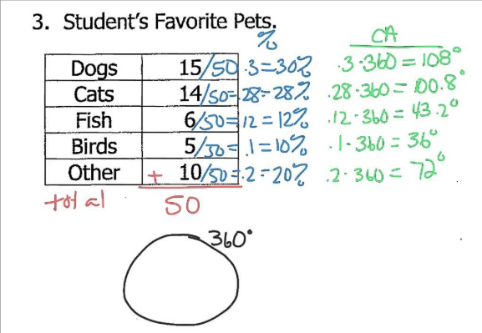  Complete a bar chart A bar chart uses height of bars  To represent frequency.
Key Facts & Formulas

Pie chart
Step 1: Calculate total frequency by adding all groups together.
Step 2: Take each number and divide it by total then multiply by 100.
STEP 3: Draw a circle with a radius.
Step 4: Measure and draw each section with a protractor.
Pictogram
The most important part of a pictogram is the KEY.
It tells you how much each symbol is worth.
Tally chart
Remember to cross off each piece of data. Record it using the five bar gate. This makes it easier to
read the frequency.

