Science Home learning
We hope you are all doing well at home, well done for doing your science work :-). Below are the email addresses for all Science staff. Do not hesitate to contact any of us with any questions. We even have twitter! Twitter Link: @Dearnescience
Jamie.venning@astreadearne.org, Thomas.bagnall@astreadearne.org, Danie.cadman@astreadearne.org, sean.guy@astreadearne.org, Kayleigh.smith@astreadearne.org, Robert.gray@astreadearne.org, Vicky.conway@astreadearne.org, dawn.brough@astreadearne.org, Hannah.szabo@astreadearne.org, Richard.white@astreadearne.org, victor.oczadly@astreadearne.org,
Topic: Chemistry Unit: Atomic Structure & The Periodic Table
Lesson 1. Atoms, elements and compounds
Lesson 2. Mixtures
Lesson 3. Mixtures: Filtration, Crystallisation and Distillation
Lesson 4. The development of the model of the atom
Lesson 5. Relative electrical charges of subatomic particles / Size and mass of atoms / Relative atomic mass
Lesson 6. Electronic structure
Lesson 7. The periodic table / History of the Periodic Table
Lesson 8. Metals and non-metals
Lesson 9. Group 1 Alkali Metals
Lesson 10. Group 0 and group 7 elements
Lesson 11. (Triple only) Properties of transition metals – comparison with group 1 elements.
Lesson 12. (Triple only) Properties of transition metals – typical properties

Lesson 1: Title: Atoms, Elements & Compounds Year: 10
Topic: Chemistry Unit: Atomic Structure & The Periodic Table
Date Set:

Learning Objectives:
- Use the names and symbols of the first 20 elements in the periodic table, the elements in Groups 1 and 7, and other elements in this specification
- Name compounds of these elements from given formulae or symbol equations
- Write word equations for the reactions in this specification
- Write formulae and balanced chemical equations for the reactions in this specification.

Information to read / watch:
https://classroom.thenational.academy/lessons/atoms-elements-and-compounds-6cv3ge
https://classroom.thenational.academy/lessons/chemical-formulae-and-conservation-of-mass-6ngk4c
https://www.bbc.co.uk/bitesize/guides/zy4pmsg/revision/1
FOUNDATION https://app.senecalearning.com/classroom/course/4c2bb850-1d46-11e8-840a-ed991cd3461d/section/e2b2f230-1e08-11e8-9c3c-ada0d86b7563/session
https://app.senecalearning.com/classroom/course/4c2bb850-1d46-11e8-840a-ed991cd3461d/section/cadcf267-9c0a-47fb-87da-8ebac90df2a1/session
HIGHER
https://app.senecalearning.com/classroom/course/e39e7f70-d100-11e7-9b85-bbf8589a9044/section/45ada5b0-d101-11e7-9b85-bbf8589a9044/session
https://app.senecalearning.com/classroom/course/e39e7f70-d100-11e7-9b85-bbf8589a9044/section/2ba6dc30-d44f-11e7-a770-ab5143c60c9e/session
Application:
Task 1: Knowledge based questions (e.g. identifying elements from symbols, identify symbol from position in periodic table).
Task 2: Q3 in activities. Naming compounds from formulae.
Task 3: Writing equations in different forms for different reactions.

Use the names and symbols of the first 20 elements in the periodic table, the elements in Groups 1 and 7, and other elements in this specification
Q1. Use the periodic table on the Data Sheet to help you to answer these questions.
(a) Write the symbol for helium.
_________________________________________________________
(1)
(b) Write the symbol for potassium.
_________________________________________________________
(1)
(c) Write the name of the element which has the symbol Be.
_________________________________________________________
(1)
(d) Write the name of the element which has the symbol Si.
_________________________________________________________
(1)

(e) Write down the symbol of an element in group 1 other than Lithium, Sodium, and potassium.
_________________________________________________________
(1)

(f) Write down the symbol of an element in group 7 other than Fluorine, Bromine, and Iodine.
_________________________________________________________
(1)

Q2. The periodic table on the Data Sheet may help you to answer these questions.
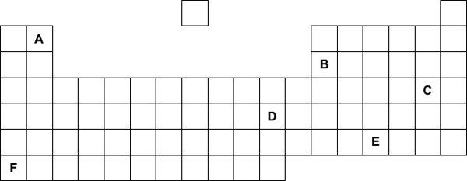
(a) Part of the periodic table is shown below.
The letters are not the symbols of the elements.
Choose your answers only from the letters shown in the periodic table above.
Which letter, A, B, C, D, E or F, represents

- Aluminium. __________ (1)
- Beryllium. __________ (1)
- An alkali metal. __________ (1)
- Ag. __________ (1)
- A Group 7 element. __________ (1)

Name compounds of these elements from given formulae or symbol equations
Q3. Use the Periodic table to name the following compounds.
- H₂O _____________________________________ (1)
- CO₂ _____________________________________ (1)
- NaCl _____________________________________ (1)
- KCl _____________________________________ (1)
- CuCl₂ _____________________________________ (1)
- CaCO₃ _____________________________________ (1)
- MgSO₄ _____________________________________ (1)

Name compounds of these elements from given formulae or symbol equations
Q3. Use the Periodic table and the list below to name the following compounds.
Calcium carbonate, Potassium Chloride, Magnesium Sulphate, Carbon dioxide,
Copper Chloride, water, Sodium Chloride.

- H₂O _____________________________________ (1)
- CO₂ _____________________________________ (1)
- NaCl _____________________________________ (1)
- KCl _____________________________________ (1)
- CuCl₂ _____________________________________ (1)
- CaCO₃ _____________________________________ (1)
- MgSO₄ _____________________________________ (1)
Name compounds of these elements from given formulae or symbol equations
Q3. Use the Periodic table and the information below to match up the compound formula to their name.

Chloride compounds contain Chlorine (Cl) e.g. Lithium Chloride (Lithium and chlorine = LiCl)
Carbonate compounds contain (CO₃) e.g. Sodium carbonate (Sodium and CO₃ = Sodium carbonate)
Sulphate compounds contain Sulphur (S) e.g. Potassium sulphate (potassium and sulphur = KSO₄)

- H₂O Potassium Chloride (1)
- CO₂ Calcium carbonate (1)
- NaCl Magnesium Sulphate (1)
- KCl Sodium Chloride (1)
- CuCl₂ Carbon dioxide (1)
- CaCO₃ Copper Chloride (1)
- MgSO₄ Water (1)

Write word equations for the reactions in this specification
Write formulae and balanced chemical equations for the reactions in this specification.

The chemicals we have at the start of a reaction are called reactants, they react together. When a chemical reaction takes place the atoms in these substances are rearranged to form new chemicals. The substances formed in a reaction are called products, they are produced.

Example
If copper oxide is reacted with magnesium using heat, it will react to produce two products, magnesium oxide and copper. We can write this as a simple word equation:

Copper oxide + Magnesium Magnesium oxide + Copper
(Reactant) + (Reactant) (Product) + (Product)

Using the Periodic table, you can work out the symbols for the chemicals in this reaction and write it as a symbol equation:

CuO + Mg MgO + Cu
(Copper & Oxygen) + (Magnesium) (Magnesium & Oxygen) + (Copper)
Copper oxide + Magnesium Magnesium oxide + Copper

See Help sheet for balancing equations.

Q4. Write the word equations, symbol equations and balanced symbol equations for the following reactions.

Methane (CH₄) reacts with oxygen (O₂) to produce carbon dioxide (CO₂) and water (H₂O).

(i)Write the word equation for this reaction

________________________________________________________________ (1)

(ii) Write the symbol equation for this reaction

________________________________________________________________ (1)

(iii) Write the balanced symbol equation for this reaction

_________________________________________________________________ (1)

Hydrogen (H₂) reacts with oxygen (O₂) to produce water (H₂O).

(i)Write the word equation for this reaction

________________________________________________________________ (1)

(ii) Write the symbol equation for this reaction

________________________________________________________________ (1)

(iii) Write the balanced symbol equation for this reaction

_______________________________________________________________ (1)

Magnesium (Mg) reacts with hydrochloric acid (HCl) to produce Magnesium chloride

(MgCl₂) and hydrogen (H₂).

(i)Write the word equation for this reaction

________________________________________________________________ (1)

(ii) Write the symbol equation for this reaction

________________________________________________________________ (1)

(iii) Write the balanced symbol equation for this reaction

_______________________________________________________________ (1)

Lesson 2: Title: Mixtures Year: 10
Topic: Chemistry Unit: Atomic Structure & The Periodic Table
Date Set:

Learning Objectives:
- Describe specified processes of separation
- Explain specified processes of separation
- Suggest suitable separation and purification techniques for mixtures when given appropriate information.
Information to read / watch:
https://classroom.thenational.academy/lessons/mixtures-filtration-and-crystallisation-60u38e
https://www.bbc.co.uk/bitesize/guides/z3jy6yc/revision/1
https://app.senecalearning.com/classroom/course/55c3c9d0-1be7-11e8-8a14-e5ed980bc25f/section/593ad2b0-1be8-11e8-8a14-e5ed980bc25f/session
Application:
Task 1: Structured questions involving describing techniques and explaining how they work
Task 2: Multiple choice questions relating mixture and separation techniques.

.

- Give an example of when chromatography is useful. (1 marks)
__________________________________________________________________________________________________________________________________________________
- Describe the process of chromatography. (3 marks)
____________________________________________________________________________________________________________________________________________________________________________________________________________________________________________________________________________________________________

- Explain why chromatography works. (2 marks)
____________________________________________________________________________________________________________________________________________________________________________________________________________________________________________________________________________________________________
- What type of substances is filtration useful for separating? Give an example. (2 marks)
____________________________________________________________________________________________________________________________________________________Describe the process of filtration. (4 marks)
____________________________________________________________________________________________________________________________________________________________________________________________________________________________________________________________________________________________________
- Explain the process of filtration using sand and water as an example. (3 marks)
____________________________________________________________________________________________________________________________________________________________________________________________________________________________________________________________________________________________________
- Describe the process of magnetism as a separation technique. (1 marks)
__________________________________________________________________________________________________________________________________________________
- Explain the process of magnetism as a separation technique. (2 marks)
____________________________________________________________________________________________________________________________________________________________________________________________________________________________________________________________________________________________________
- What type of substances is evaporation useful for separating? Give an example. (2 marks)
___________________________________________________________________________________________________________________________________________________________________________________________________________________________

- Describe the process of evaporation. (4 mark)
____________________________________________________________________________________________________________________________________________________________________________________________________________________________________________________________________________________________________
- Explain the process of evaporation. (3 mark)
____________________________________________________________________________________________________________________________________________________________________________________________________________________________________________________________________________________________________

- What type of substances is distillation useful for separating? Give an example. (2 marks)
___________________________________________________________________________________________________________________________________________________________________________________________________________________________

- Describe the process of distillation. (4 mark)
____________________________________________________________________________________________________________________________________________________________________________________________________________________________________________________________________________________________________
- Explain the process of distillation. (4 mark)
____________________________________________________________________________________________________________________________________________________________________________________________________________________________________________________________________________________________________

- In the process of distillation, why does salt not evaporate? (1 mark)
__________________________________________________________________________________________________________________________________________________

- Which is the best way to get salt from salty water? (1 mark)

Match task to separation techniques
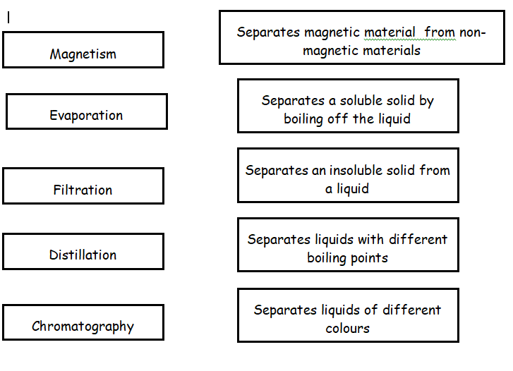
Lesson 3: Title: Mixtures –Filtration, Crystallisation & Distillation Year: 10
Topic: Chemistry Unit: Atomic Structure & The Periodic Table
Date Set:

Learning Objectives:
- Describe specified processes of separation
- Explain specified processes of separation

Information to read / watch:

https://classroom.thenational.academy/lessons/separation-by-distillation-75jk2r
https://classroom.thenational.academy/lessons/separation-by-chromatography-69j3jr
https://app.senecalearning.com/classroom/course/e39e7f70-d100-11e7-9b85-bbf8589a9044/section/a025fdb0-f778-11e7-b0a1-a105274a5dcd/session

Application:
Task : Construct a method for the filtration and evaporation of sea water.
Method for separation of seawater using filtration and evaporation.
Equipment:
Filtration:
- 250ml beaker x2
- Filter funnel
- Filter paper
- Glass rod
- Mixture of seawater and sand
Evaporation:
- Bunsen burner
- Heat proof mat
- Gauze
- Tripod
- Evaporating basin
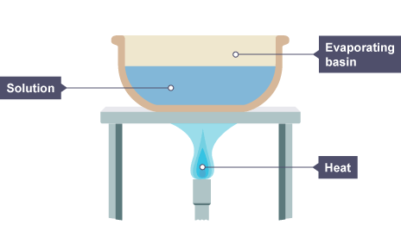
Diagram:
Filtration Diagram
Gauze
Tripod

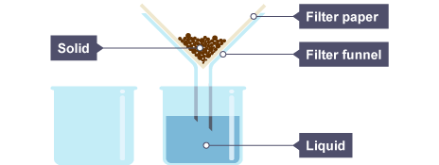

Beaker

Evaporation Diagram

- Using the equipment list and diagrams sort the steps for the filtration practical into the correct order.
Method:
Filtration:

Carefully pour the mixture from the beaker into the filter funnel.
N.B. Do not pour the liquid above the level of the filter paper.

Tidy away the practical equipment.

Place the filter paper into the filter funnel.

Stir the mixture well with a glass rod.

Add the seawater and sand mixture to a beaker.

Place the filter funnel and filter paper into the second beaker (the empty one).

Allow the mixture to filter through the filter paper.
N.B. Do not poke the mixture through.

Once enough liquid has been collected in the beaker move onto the evaporation part of the practical.

- Using the equipment list and diagrams sort the steps for the evaporation practical into the correct order.
Method:
Evaporation:

Using the Bunsen burner heat the solution.

Once the evaporating basin has cooled, remove from the tripod, and allow the remaining solution to evaporate overnight.

Once it has cooled tidy away the practical equipment.

Add the filtered solution from the second beaker to the evaporating basin.

Set up the equipment as in the diagram.

When the solution has nearly fully evaporated turn off the Bunsen burner. N.B. Be careful the solution might start to spit out.

Lesson 4: Title: History of the Atomic Structure Model Year: 10
Topic: Chemistry Unit: Atomic Structure & The Periodic Table
Date Set:

Learning Objectives:
- List milestones in the history of atomic structure in chronological order.
- Describe the difference between the plum pudding model of the atom and the nuclear model of the atom.
- Describe why the new evidence from the scattering experiment led to a change in the atomic model.

Information to read / watch:
https://classroom.thenational.academy/lessons/development-of-the-atomic-model-6crp2t
https://www.bbc.co.uk/bitesize/guides/zwn8b82/revision/1
FOUNDATION https://app.senecalearning.com/classroom/course/55c3c9d0-1be7-11e8-8a14-e5ed980bc25f/section/62cd6270-1be8-11e8-8a14-e5ed980bc25f/session
HIGHER
https://app.senecalearning.com/classroom/course/e39e7f70-d100-11e7-9b85-bbf8589a9044/section/20e15a80-d109-11e7-9b85-bbf8589a9044/session
Application:
Task 1: Add name of scientist and name of model/key discovery to the blank timeline
Task 2: 4 mark exam question, with diagrams
Task 3: 6 mark multistep exam question, with diagrams and a great deal of written description, about the gold leaf scattering experiment and the nature of the importance of scientific method.
Task1: List milestones in the history of atomic structure in chronological order.
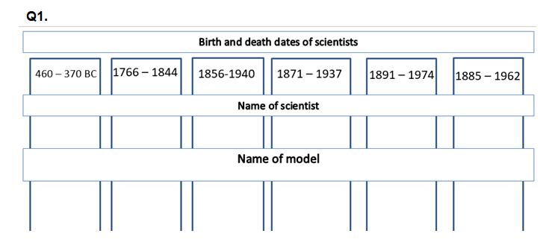
Task Q2:
In the early part of the 20th century, scientists used the ‘plum pudding’ model to explain the structure of the atom.
Following work by Rutherford and Marsden, a new model of the atom, called the ‘nuclear’ model, was suggested.

Describe the differences between the two models of the atom.
_______________________________________________________________________
_______________________________________________________________________
_______________________________________________________________________
_______________________________________________________________________
_______________________________________________________________________
_______________________________________________________________________
_______________________________________________________________________
_______________________________________________________________________
(Total 4 marks)

Task 3:
The ‘plum pudding’ model of the atom was used by scientists in the early part of the 20th century to explain atomic structure.
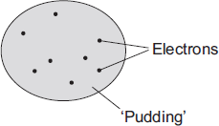
(a) Those scientists knew that atoms contained electrons and that the electrons had a negative charge. They also knew that an atom was electrically neutral overall.
What did this allow the scientists to deduce about the ‘pudding’ part of the atom?
___________________________________________________________________
___________________________________________________________________
(1)
(b) An experiment, designed to investigate the ‘plum pudding’ model, involved firing alpha particles at a thin gold foil.
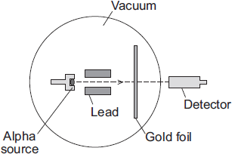
If the ‘plum pudding’ model was correct, then most of the alpha particles would go straight through the gold foil. A few would be deflected, but by less than 4°.
The results of the experiment were unexpected. Although most of the alpha particles did go straight through the gold foil, about 1 in every 8 000 was deflected by more than 90°.
Why did this experiment lead to a new model of the atom, called the nuclear model, replacing the ‘plum pudding’ model?
___________________________________________________________________
___________________________________________________________________
___________________________________________________________________
(1)
(c) The diagram shows the paths, A, B and C, of three alpha particles. The total number of alpha particles deflected through each angle is also given.
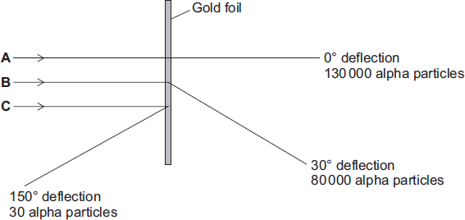
(i) Using the nuclear model of the atom, explain the three paths, A, B and C.
A ____________________________________________________________
______________________________________________________________
B ____________________________________________________________
______________________________________________________________
C ____________________________________________________________
______________________________________________________________
(3)
(ii) Using the nuclear model, the scientist E. Rutherford devised an equation to predict the proportion of alpha particles that would be deflected through various angles.
The results of the experiment were the same as the predictions made by Rutherford.
What was the importance of the experimental results and the predictions being the same?
______________________________________________________________
______________________________________________________________
(1)
(Total 6 marks)

Lesson 5: Title: Sub-atomic particles Year: 10
Topic: Chemistry Unit: Atomic Structure & The Periodic Table
Date Set:

Learning Objectives:
- Use the nuclear model to describe atoms.
- Calculate the numbers of protons, neutrons and electrons in an atom or ion, given its atomic number and mass number.
- Relate size and scale of atoms to objects in the physical world.
Information to read / watch:
https://classroom.thenational.academy/lessons/atomic-structure-6crk8d
https://www.bbc.co.uk/bitesize/guides/zwn8b82/revision/3
FOUNDATION https://app.senecalearning.com/classroom/course/55c3c9d0-1be7-11e8-8a14-e5ed980bc25f/section/c92b8ea1-641c-4f8b-a8c7-a0e3cc4c1003/session
HIGHER https://app.senecalearning.com/classroom/course/e39e7f70-d100-11e7-9b85-bbf8589a9044/section/0a85c1cc-37ae-4eef-94c0-955512fb4c32/session
Application:
Task 1: Complete the 4 mark question.
Task 2: Students complete details of given atoms.
Task 3: Complete calculations of size of nuclei, atomic and molecular radii in standard form.
Task1:
Describe the structure of the atom according to the nuclear model.
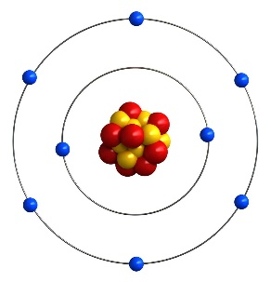
________________________________________________________________________________________________________________________________________________________________________________________________________________________________________________________________________________________________________________________________________________________________________________________ [4]

Task 2:
Complete the table (Boron has been given completed as a WAGOLL)

Task3:
- What prefix would you use to describe objects the size of red blood cells?
- What prefix would you use to describe objects the size of the Milky Way Galaxy?
- If a red blood cell is 1,000,000 times smaller than a human (1x10⁻⁶ is 1 with 6 zeros after it).
    - How many times smaller is a proton than an atom?
    - How many times bigger is the Milky Way Galaxy than the Earth-Sun distance?

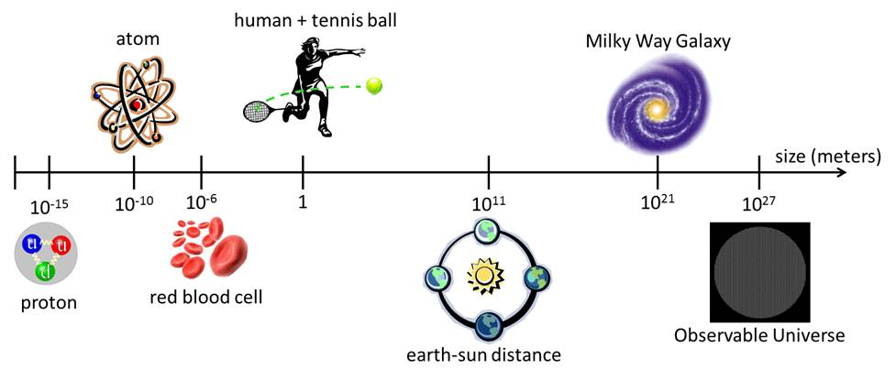
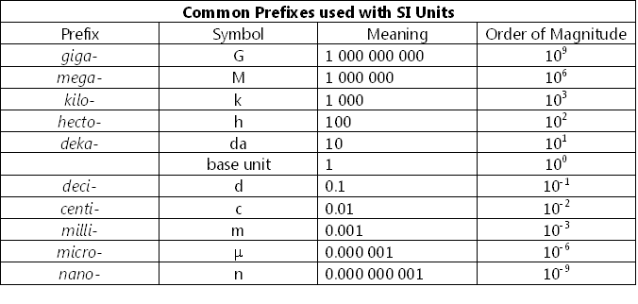

The size of atoms

Atoms are very small, having a radius of about 0.1nm (1 x 10⁻¹⁰ m)
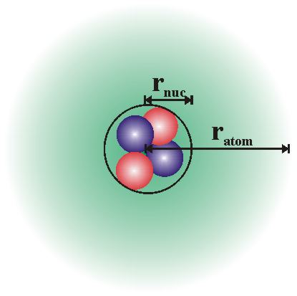(Not to scale)
The radius of a nucleus is less than 1/10 000 of that of the atom!

How many nanometres is the nucleus?

……………………….nm
How many metres is the nucleus? (Write in standard form)
…………………………m

Lesson 6: Title: Relative atomic mass and electronic structures Year: 10
Topic: Chemistry Unit: Atomic Structure & The Periodic Table
Date Set:

Learning Objectives:
- Represent the electronic structures of the first twenty elements of the periodic table in both forms.
- Calculate the relative atomic mass of an element given the percentage abundance of its isotopes.
Information to read / watch:
https://classroom.thenational.academy/lessons/isotopes-ccwp4c
FOUNDATION https://app.senecalearning.com/classroom/course/55c3c9d0-1be7-11e8-8a14-e5ed980bc25f/section/a5f05a99-51f4-4e26-84cc-f0aeb89542d0/session
https://app.senecalearning.com/classroom/course/55c3c9d0-1be7-11e8-8a14-e5ed980bc25f/section/63365d70-1be8-11e8-8a14-e5ed980bc25f/session
HIGHER https://app.senecalearning.com/classroom/course/e39e7f70-d100-11e7-9b85-bbf8589a9044/section/03cd5020-f779-11e7-b0a1-a105274a5dcd/session
https://app.senecalearning.com/classroom/course/e39e7f70-d100-11e7-9b85-bbf8589a9044/section/6929e8fc-b4bb-43d0-9407-ac689e8817ad/session
Application:
Task 1: Complete the empty electron shells for the first 20 atoms.
Task 2: Complete 3 exam type questions to demonstrate that you can calculate the RAM of elements with multiple isotopes.

Task1:
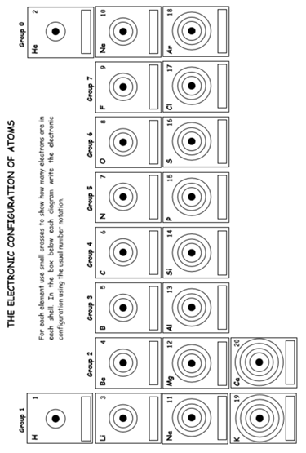

Task2:
This question is about atoms and isotopes.
(a) Atoms contain protons, neutrons and electrons.
A lithium atom has the symbol
Explain, in terms of sub-atomic particles, why the mass number of this lithium atom is 7.
___________________________________________________________________
___________________________________________________________________
___________________________________________________________________
___________________________________________________________________
___________________________________________________________________
___________________________________________________________________
(3)
Q3.
This question is about the structure of the atom.
(a) Complete the sentences.
Choose answers from the box.
Each word may be used once, more than once, or not at all.

electron |  | ion |  | neutron
 | nucleus |  | proton
The centre of the atom is the _______________________ . The two types of particle in the centre of the atom are the proton
and the _______________________ .
James Chadwick proved the existence of the _______________________ .
Niels Bohr suggested particles orbit the centre of the atom. This type of particle
is the _______________________ .
The two types of particle with the same mass are the neutron
and the _______________________ .
(5)

The table below shows information about two isotopes of element X.

 | Mass number | Percentage (%) abundance
Isotope 1 | 63 | 70
Isotope 2 | 65 | 30
(b) Calculate the relative atomic mass (A_{r}) of element X using the equation:
Use the table above.
Give your answer to 1 decimal place.
___________________________________________________________________
___________________________________________________________________
___________________________________________________________________
___________________________________________________________________
A_{r} = _________________
(2)

(c) Element X has two isotopes. Their mass numbers are 69 and 71
The percentage abundance of each isotope is:
• 60% of ⁶⁹X
• 40% of ⁷¹X
Estimate the relative atomic mass of element X.
Tick one box.

< 69.5
Between 69.5 and 70.0
Between 69.5 and 70.0
Between 70.0 and 70.5
> 70.5
(1)

(d) There are two isotopes of element A. Information about the two isotopes is shown in the table below.

Mass number of the isotope | 6 | 7
Percentage abundance | 92.5 | 7.5
Use the information in the table above above to calculate the relative atomic mass of element A.
Give your answer to 2 decimal places.
___________________________________________________________________
___________________________________________________________________
___________________________________________________________________
___________________________________________________________________
___________________________________________________________________
___________________________________________________________________
___________________________________________________________________
Relative atomic mass = _______________________
(4)

Lesson 7: Title: The Periodic Table / History of the Periodic table. Year: 10
Topic: Chemistry Unit: Atomic Structure & The Periodic Table
Date Set:

Learning Objectives:
- Explain how the position of an element in the periodic table is related to the arrangement of electrons in its atoms and hence to its atomic number
- Predict possible reactions and probable reactivity of elements from their positions in the periodic table.
- Describe the steps in the development of the periodic table.
Information to read / watch:
https://classroom.thenational.academy/lessons/electron-configuration-and-the-periodic-table-61jp4c
https://classroom.thenational.academy/lessons/periodic-table-development-6cwp8t

FOUNDATION https://app.senecalearning.com/classroom/course/4c2bb850-1d46-11e8-840a-ed991cd3461d/section/e2b2f230-1e08-11e8-9c3c-ada0d86b7563/session
https://app.senecalearning.com/classroom/course/4c2bb850-1d46-11e8-840a-ed991cd3461d/section/cadcf267-9c0a-47fb-87da-8ebac90df2a1/session
HIGHER
https://app.senecalearning.com/classroom/course/e39e7f70-d100-11e7-9b85-bbf8589a9044/section/45ada5b0-d101-11e7-9b85-bbf8589a9044/session
https://app.senecalearning.com/classroom/course/e39e7f70-d100-11e7-9b85-bbf8589a9044/section/2ba6dc30-d44f-11e7-a770-ab5143c60c9e/session
Application:
Task 1 On a blank Periodic Table label the following
- Group
- Period
- Name a minimum of 4 groups
- Colour the groups in different colours
- Divide metals from non-metals
Task 2: : Complete the table with the correct number of electrons in each shell and answer the question which links the number of electrons to the position of the element on the Periodic Table.
Task3: Answer questions about the size of atoms in a group and the effect of this on reactivity.
Task 4: Answer 2 multi-step exam questions about the development of the Periodic Table – specifically the work of Newlands and Mendeleev.

Misconceptions:

Additional Websites:
Task 1: On a blank Periodic Table label the following
- Group
- Period
- Name a minimum of 4 groups
- Colour the groups in different colours
- Divide metals from non-metals

Task2:
____________________________________________________________________________________________________________________________________________________________________________________________________________________________________________________________________________________________________________________________________________________________________________________________

Task3: Predict possible reactions and probable reactivity of elements from their positions in the periodic table.
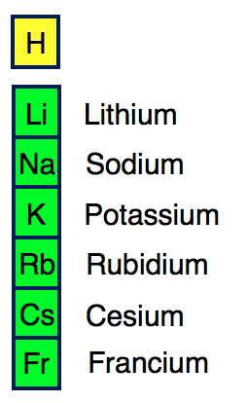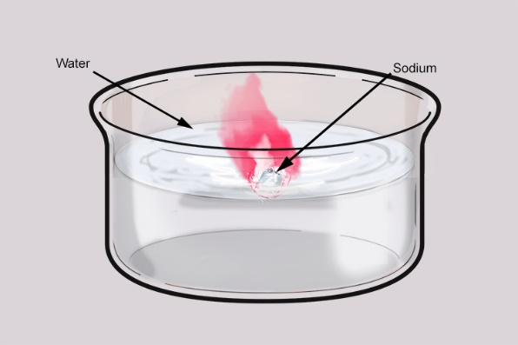
Elements in the same group have similar properties and reactions.
- Describe the size of the atoms as you go down the group.

- What effect does this have on the reactivity of the elements as you go down the group?

- Does this mean that Potassium is more or less reactive than Sodium? Explain how you know.

- Describe what you think the reaction between Potassium and water would look like.

Task4: Describe the steps in the development of the periodic table.
In 1866 John Newlands produced an early version of the periodic table.
Part of Newlands’ periodic table is shown below.

Column | 1 | 2 | 3 | 4 | 5 | 6 | 7
 | H | Li | Be | B | C | N | O
 | F | Na | Mg | Al | Si | P | S
 | Cl | K | Ca | Cr | Ti | Mn | Fe
Newlands’ periodic table arranged all the known elements into columns in order of their atomic weight.
Newlands was trying to show a pattern by putting the elements into columns.
(a) Iron (Fe) does not fit the pattern in column 7.
Give a reason why.
___________________________________________________________________
___________________________________________________________________
(1)
(b) In 1869 Dmitri Mendeleev produced his version of the periodic table.
Why did Mendeleev leave gaps for undiscovered elements in his periodic table?
___________________________________________________________________
___________________________________________________________________
(1)
(c) Newlands and Mendeleev placed the elements in order of atomic weight.
Complete the sentence.
The modern periodic table places the elements in order of
______________________ .
(1)
(d) Lithium, sodium and potassium are all in Group 1 of the modern periodic table.
Explain why.
___________________________________________________________________
___________________________________________________________________
___________________________________________________________________
(2)
(Total 5 marks)
(a) Dmitri Mendeleev was one of the first chemists to classify the elements by arranging them in order of their atomic weights. His periodic table was published in 1869.
How did Mendeleev know that there must be undiscovered elements and how did he take this into account when he designed his periodic table?
___________________________________________________________________
___________________________________________________________________
___________________________________________________________________
___________________________________________________________________
(2)
(b) By the early 20th century protons and electrons had been discovered.
Describe how knowledge of the numbers of protons and electrons in atoms allow chemists to place elements in their correct order and correct group.
___________________________________________________________________
___________________________________________________________________
___________________________________________________________________
___________________________________________________________________
___________________________________________________________________
(3)
(c) The transition elements are a block of elements between Groups 2 and 3 of the periodic table.
(i) Transition elements have similar properties.
Explain why, in terms of electronic structure.
______________________________________________________________
______________________________________________________________
______________________________________________________________
______________________________________________________________
(2)
(ii) There are no transition elements between the Group 2 element magnesium and the Group 3 element aluminium.
Give a reason why, in terms of electronic structure.
______________________________________________________________
______________________________________________________________
______________________________________________________________
(1)
(Total 8 marks)

Lesson 8: Title: Metals and non-metals Year: 10
Topic: Chemistry Unit: Atomic Structure & The Periodic Table
Date Set:

Learning Objectives:
- Explain the differences between metals and non-metals on the basis of their characteristic physical and chemical properties.
- Explain how the atomic structure of metals and non-metals relates to their position in the periodic table
- Explain how the reactions of elements are related to the arrangement of electrons in their atoms and hence to their atomic number.
Information to read / watch:
https://classroom.thenational.academy/lessons/why-elements-react-6cuk4d
https://www.bbc.co.uk/bitesize/guides/ztrxdxs/revision/1
FOUNDATION https://app.senecalearning.com/classroom/course/55c3c9d0-1be7-11e8-8a14-e5ed980bc25f/section/6387b1c0-1be8-11e8-8a14-e5ed980bc25f/session
HIGHER https://app.senecalearning.com/classroom/course/e39e7f70-d100-11e7-9b85-bbf8589a9044/section/ea758050-d42f-11e7-8473-7b3349c67dde/session
Application:
Task 1: Complete the table comparing metal and non-metal physical properties.
Task 2: Multistep exam question about the differences in properties of group I metals and Transition elements.
Task 3: Multistep exam question which provides information about the properties of an “unknown” element including the formula of the compound produced when reacted with Oxygen.

Task 1:

Task 2:
An atom of aluminium has the symbol
(a) Give the number of protons, neutrons and electrons in this atom of aluminium.
Number of protons _____________________
Number of neutrons _____________________
Number of electrons _____________________
(3)
(b) Why is aluminium positioned in Group 3 of the periodic table?
___________________________________________________________________
(1)
(c) In the periodic table, the transition elements and Group 1 elements are metals.
Some of the properties of two transition elements and two Group 1 elements are shown in the table below.

 | Transition elements |  | Group 1 elements
 | Chromium | Iron | Sodium | Caesium
Melting point  in °C | 1857 | 1535 | 98 | 29
Formula of  oxides | CrO | FeO | Na₂O | Cs₂O
 | Cr₂O₃ | Fe₂O₃
 | CrO₂ | Fe₃O₄
 | CrO₃
Use your own knowledge and the data in the table above to compare the chemical and physical properties of transition elements and Group 1 elements.
___________________________________________________________________
___________________________________________________________________
___________________________________________________________________
___________________________________________________________________
___________________________________________________________________
___________________________________________________________________
___________________________________________________________________
(6)
(Total 10 marks)
Q2c. Support
- Compare the melting points of the Group I metals with the Transition elements – are they similar/different and if they are different how?
- Compare the formulae of the oxides – do the Group I metal oxide have a pattern? DO the Transition elements have a pattern? If there is a pattern is it the same or different to the pattern for Group I metals?
- How many oxides do the metals in Group I and the Transition elements form?

Task 3.
Read the following information about an element X.
The element X melts above 600°C. It conducts electricity at room temperature. It burns in oxygen to form an oxide. When the oxide is mixed with water it turns Universal Indicator blue.
The oxide of X is a white solid at room temperature. It has the formula XO and contains the ion X²⁺.
The element X reacts with chlorine to form a chloride with a high melting point. The chloride conducts electricity when molten and it is soluble in water.
(a) From the information give three pieces of evidence which suggest that X is a metal.
1. _________________________________________________________________
___________________________________________________________________
2. _________________________________________________________________
___________________________________________________________________
3. _________________________________________________________________
___________________________________________________________________
(3)
(b) In which Group of the Periodic Table should X be placed? Give a reason for your answer.
Group _____________________________________________________________
Reason ____________________________________________________________
___________________________________________________________________
(2)
(Total 5 marks)

Lesson 9: Title: Group one metals Year: 10
Topic: Chemistry Unit: Atomic Structure & The Periodic Table
Date Set:

Learning Objectives:
- Describe the reactions of the first three alkali metals with oxygen, chlorine and water.
- Explain how properties of the elements in Group 1 depend on the outer shell of electrons of the atoms.
- Predict properties from given trends down the group.

Information to read / watch:
https://classroom.thenational.academy/lessons/group-1-cdk68r
https://www.kayscience.com/c23-group-1-chemical-reactions-oxygen.html
https://www.kayscience.com/c23-group-1-chemical-reactions-chlorine.html
https://www.kayscience.com/c23-group-1-chemical-reactions-water.html
FOUNDATION https://app.senecalearning.com/classroom/course/55c3c9d0-1be7-11e8-8a14-e5ed980bc25f/section/64d42ef0-1be8-11e8-8a14-e5ed980bc25f/session
HIGHER https://app.senecalearning.com/classroom/course/e39e7f70-d100-11e7-9b85-bbf8589a9044/section/a6a6f570-d43e-11e7-a770-ab5143c60c9e/session
Application:
Task 1: Complete the table of the reactions of Lithium, Sodium and Potassium with water, oxygen and chlorine.
Task 2: Multistep exam question.
Task 3: : Multistep exam question which also interleaves previous work on Periodic Table.

Task 1:
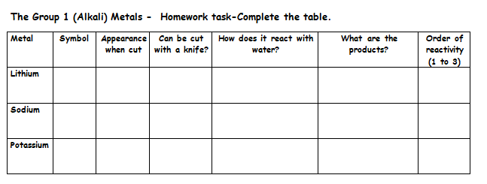
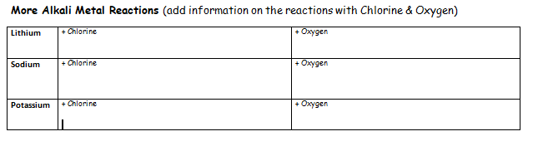
Task 2:
Q1.
The elements in Group 1 are known as the alkali metals.
Which three of the following are properties of alkali metals?
Place a tick () in the box against each correct property.

Hard, tough and strong
Low density
Form hydroxides that dissolve in water
React quickly with water
Used as catalysts
Used to make electric cables
(Total 3 marks)

Q2.
The elements in the periodic table are arranged in groups.
(a) What is similar about the elements in the same group?
Tick one box.

Chemical properties
Atomic numbers
Relative atomic masses
(1)
(b) Figure 1 shows the arrangement of electrons in an atom.
Figure 1
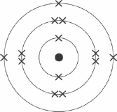
What group of the periodic table is this atom in?
Group _________________
(1)
(c) Why are the elements in Group 0 unreactive?
Tick one box.

They are all gases at room temperature
They all have the same atomic number
They are all in the same group of the periodic table
They all have a stable arrangement of electrons
(1)
(d) A teacher demonstrates the reaction of some alkali metals with water.
Look at Figure 2.
Figure 2
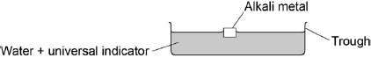
The students write what they see.
1. The alkali metals float on water.
2. The alkali metals fizz when they react with water.
3. The universal indicator changes from green to purple.
4. The sodium disappears faster than the lithium.
Give a reason for each of the four things that the students see.
1. The alkali metals float on water.
Reason ___________________________________________________________
___________________________________________________________________
2. The alkali metals fizz when they react with water.
Reason ___________________________________________________________
___________________________________________________________________
3. The universal indicator changes from green to purple.
Reason ___________________________________________________________
___________________________________________________________________
4. The sodium disappears faster than the lithium.
Reason ___________________________________________________________
___________________________________________________________________
(4)

Task3:
Q1.
Lithium is in Group 1 of the periodic table.
Lithium reacts with water to produce a gas and an alkaline solution.
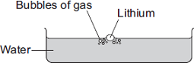
(a) (i) Name the gas produced.
______________________________________________________________
(1)
(ii) Which ion causes the solution to be alkaline?
______________________________________________________________
(1)
(b) Potassium is also in Group 1 of the periodic table.
Potassium reacts with water in a similar way to lithium.
Write down two differences you would see between the reactions of potassium and lithium with water.
1. _________________________________________________________________
___________________________________________________________________
2. _________________________________________________________________
___________________________________________________________________
(2)
(Total 4 marks)
Q2.
The elements in Group 1 of the periodic table are metals.
(a) The elements in Group 1 are called the alkali metals.
Why are they called the alkali metals?
___________________________________________________________________
___________________________________________________________________
___________________________________________________________________
___________________________________________________________________
(2)
(b) Explain the increase in reactivity of elements further down the group.
___________________________________________________________________
___________________________________________________________________
___________________________________________________________________
___________________________________________________________________
___________________________________________________________________
___________________________________________________________________
___________________________________________________________________
___________________________________________________________________
(4)
(c) Lithium oxide is an ionic compound.
Draw a dot and cross diagram to show how lithium and oxygen combine to form lithium oxide.
Only show the electrons in the outer shell of each atom.
Give the charges on the ions formed.
(4)

Lesson 10: Title: Group 7 and group 0 elements Year: 10
Topic: Chemistry Unit: Atomic Structure & The Periodic Table
Date Set:

Learning Objectives:
- Explain how properties of the elements in Group 0 and group 7 depend on the outer shell of electrons of the atoms
- Predict properties from given trends down the groups.
Information to read / watch:
https://classroom.thenational.academy/lessons/group-7-c5h36c
https://classroom.thenational.academy/lessons/group-7-displacement-69jp4c
https://www.kayscience.com/c22-group-0-chemical-and-physical-properteis.html
FOUNDATION https://app.senecalearning.com/classroom/course/55c3c9d0-1be7-11e8-8a14-e5ed980bc25f/section/fa67f5df-bc54-455b-8615-b498c3e8c629/session
HIGHER https://app.senecalearning.com/classroom/course/e39e7f70-d100-11e7-9b85-bbf8589a9044/section/69c42f52-ab40-464d-b21a-d2eb07004c9b/session
Application:
Task 1: Multistep exam question including graph skills.
Task 2: Multistep exam question comparing the Boiling points of Halogens and identifying key properties of the group.
Task 1.
The table gives the melting points of some of the elements of Group 7.

Element | Atomic number | Melting point in ºC
Fluorine | 9 | –220
Chlorine | 17 | –101
Bromine | 35 | –7
Iodine | 53 | 114
Astatine | 85 | ?
(i) Plot a graph of the melting point against atomic number.
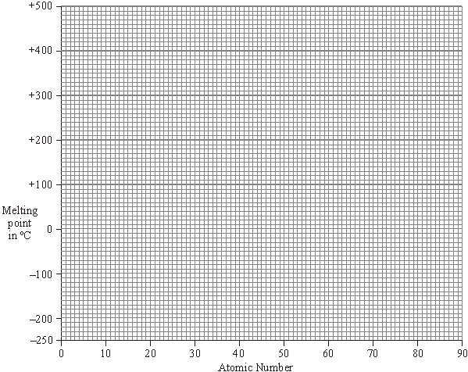
Draw a line of best fit.
Extend your line to estimate a value for the melting point of astatine.
(2)
(ii) Estimate the melting point of astatine. ____________________________ °C
(1)
(iii) Which of the Group 7 elements are solids at 20 °C?
______________________________________________________________
(1)
Task 2.
(i) Draw a diagram to show the arrangement of electrons in an atom of fluorine.

(1)
(ii) The elements of Group 7 have similar chemical properties.
Explain, in terms of electrons, why they have similar chemical properties.
______________________________________________________________
______________________________________________________________
(1)
(c) Xenon is a very unreactive element.
(i) Explain, in terms of electrons, why xenon is so unreactive.
______________________________________________________________
______________________________________________________________
______________________________________________________________
______________________________________________________________
(2)
(ii) Fluorine reacts with xenon but iodine does not.
Explain, in terms of atomic structure, why fluorine is more reactive than iodine.
______________________________________________________________
______________________________________________________________
______________________________________________________________
______________________________________________________________
______________________________________________________________
______________________________________________________________
(3)

Lesson 11: Title: Transition metals. Comparison with group 1 elements. Year: 10 Separate Science
Topic: Chemistry Unit: Atomic Structure & The Periodic Table
Date Set:

Learning Objectives:
- Describe the difference (of transition elements) compared with Group 1 in melting points, densities, strength, hardness and reactivity with oxygen, water and halogens.
- Exemplify these general properties by reference to Cr, Mn, Fe, Co, Ni, Cu.

Information to read / watch:
https://classroom.thenational.academy/lessons/comparing-the-reactivities-of-group-1-and-7-elements-6tjpac
https://www.kayscience.com/c25-explaining-group-1-reactivity.html
https://www.kayscience.com/c25-group-7-reactivity.html
https://app.senecalearning.com/classroom/course/e39e7f70-d100-11e7-9b85-bbf8589a9044/section/343821c8-77b9-4b9c-9373-002e48368f69/session

Application:
Task 1: Complete the table of Transition element uses and properties using information provided.
Task 2: Exam style questions naming the compounds of transition elements.

Task1:
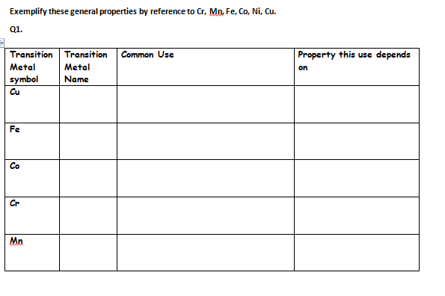
Task2:
Q1. Transition elements and their compounds have many uses.
Iron oxide and cobalt oxide have been added to the glazes on pottery for hundreds of years.
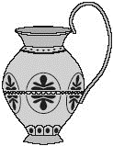
(a) State why transition metal oxides are added to pottery glazes.
.............................................................................................................................
(1)

(b) Use the table of ions on the Data Sheet to help you work out the formula of iron(III) oxide.
.............................................................................................................................

(c) Cobalt oxide is reacted with hydrogen to form cobalt.
(i) Balance the equation for this reaction.
(1)

(ii) Cobalt is mixed with other transition metals to make alloys.
These alloys are used to make cutting tools which remain sharp at very high temperatures. They can cut through other metals.
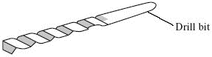
Suggest two properties of transition metals that make them suitable for making cutting tools.
1 ........................................................................................................................
...................................................................................................................
2 ........................................................................................................................
...................................................................................................................
(2)
Q2.
Niobium is a typical transition metal.
Put a tick () next to each of the four properties in the table that you would expect for Niobium.

Property
brittle
conducts heat
dull
forms coloured compounds
high melting point
low boiling point
strong
very reactive
Q3.
﻿
Sodium is a Group 1 element.
(a) (i) A small piece of sodium is added to some water containing Universal Indicator solution.
Describe what you would see happening.
______________________________________________________________
______________________________________________________________
______________________________________________________________
______________________________________________________________
______________________________________________________________
______________________________________________________________
(3)
(ii) Complete and balance the equation for the reaction of sodium with water.
___Na + ___H₂O → ____________ + H₂
(2)
(b) Francium is the most reactive element in Group 1.
Explain why in terms of electronic structure.
___________________________________________________________________
___________________________________________________________________
___________________________________________________________________
___________________________________________________________________
___________________________________________________________________
___________________________________________________________________
(3)
(c) The transition elements have different properties from the elements in Group 1.
Give two of these different properties of transition elements.
1. _________________________________________________________________
___________________________________________________________________
2. _________________________________________________________________
___________________________________________________________________
(2)
(Total 10 marks)

