**Family Take-aways**

**Goldthorpe Salvation Army**

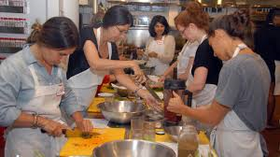

Join this class for 5 fun sessions to learn how to cook homemade versions of your favourite

take-away meals at home.

**Start Date:** Wednesday 15Th January 2020

**Duration: 5** weeks

**Time:** 9.30-12

**Cost:** Free

**This course is for 19yrs+**

**Book your place by calling 01709 722792** [**https://www.facebook.com/RotherhamCommunityLearning/**](https://www.facebook.com/RotherhamCommunityLearning/)

**Family Take-aways**

**Goldthorpe Salvation Army**



Join this class for 5 fun sessions to learn how to cook homemade versions of your favourite

take-away meals at home.

**Start Date:** Wednesday 15Th January 2020

**Duration: 5** weeks

**Time:** 9.30-12

**Cost:** Free

**This course is for 19yrs+**

**Book your place by calling 01709 722792** [**https://www.facebook.com/RotherhamCommunityLearning/**](https://www.facebook.com/RotherhamCommunityLearning/)